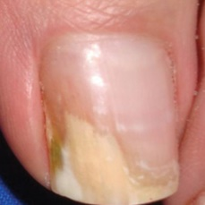fungal#37 = 0  
fungal#302 = 0  
fungal#408 = 0  
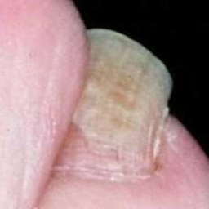fungal#393 = 0  
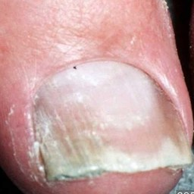fungal#54 = 0  
fungal#365 = 0  
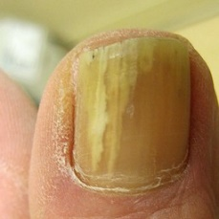fungal#367 = 0  
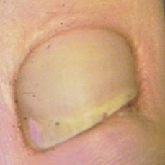fungal#315 = 0  
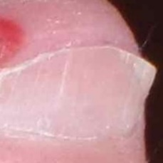fungal#178 = 0  
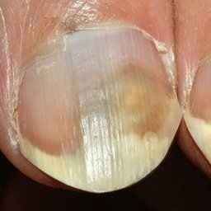fungal#353 = 0  
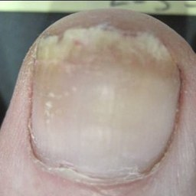fungal#232 = 0  
fungal#283 = 0  
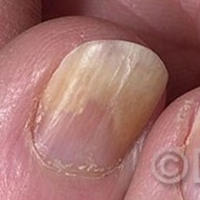fungal#31 = 0  
fungal#294 = 0  
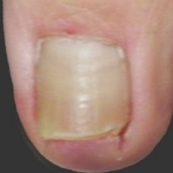fungal#13 = 0  
fungal#218 = 0  
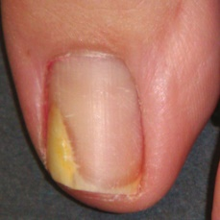fungal#119 = 0  
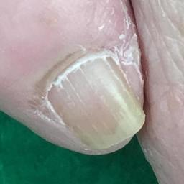fungal#537 = 0  
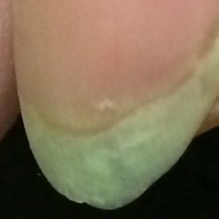fungal#275 = 0  
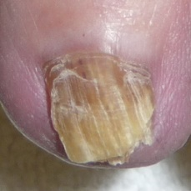fungal#267 = 0  
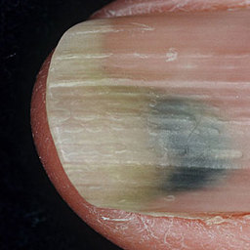fungal#485 = 0  
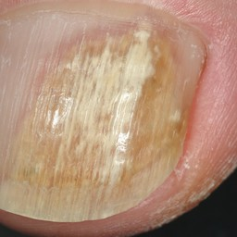fungal#146 = 0  
fungal#382 = 0  
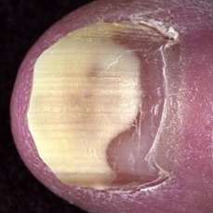fungal#368 = 0  
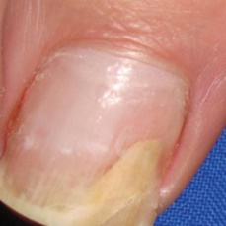fungal#36 = 0  
fungal#301 = 0  
fungal#407 = 0  
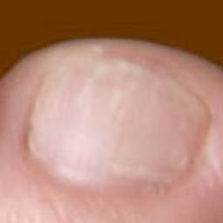fungal#78 = 0  
fungal#313 = 0  
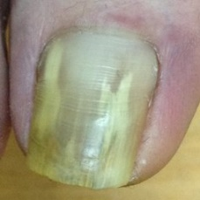fungal#111 = 0  
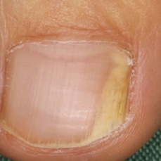fungal#513 = 0  
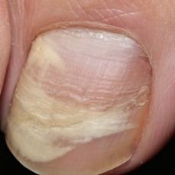fungal#144 = 0  
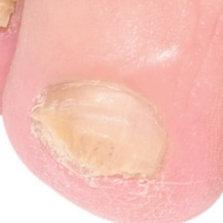fungal#420 = 0  
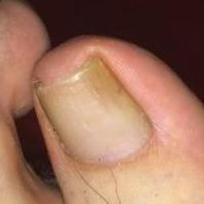fungal#236 = 0  
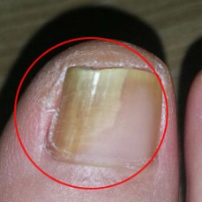fungal#583 = 0  
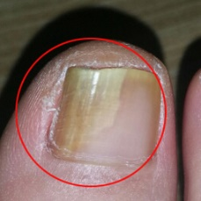fungal#596 = 0  
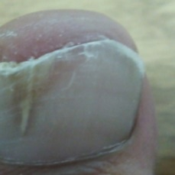fungal#524 = 0  
fungal#547 = 0  
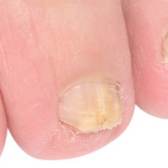fungal#423 = 0  
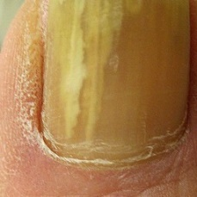fungal#363 = 0  
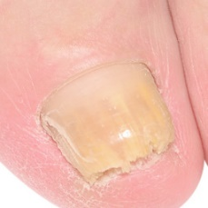fungal#419 = 0  
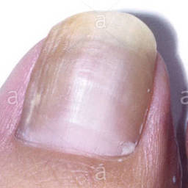fungal#104 = 0  
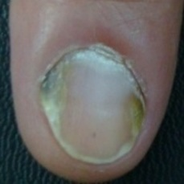fungal#82 = 0  
fungal#316 = 0  
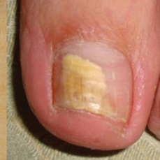fungal#440 = 0  
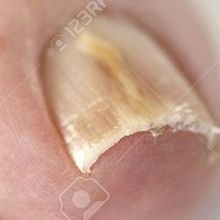fungal#88 = 0  
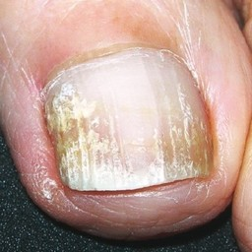fungal#484 = 0  
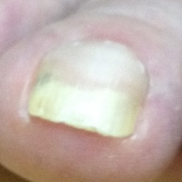fungal#460 = 0  
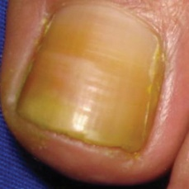fungal#398 = 0  
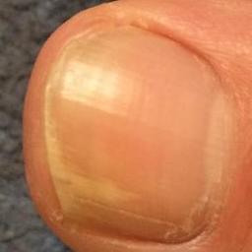fungal#129 = 0  
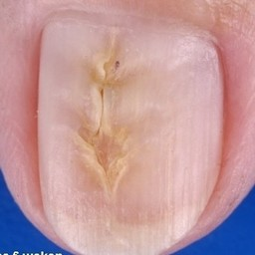fungal#238 = 0  
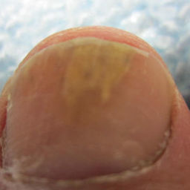fungal#543 = 0  
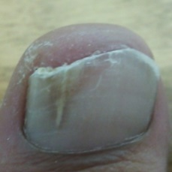fungal#523 = 0  
fungal#546 = 0  
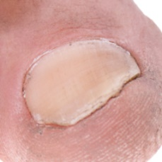fungal#86 = 0  
fungal#568 = 0  
fungal#580 = 0  
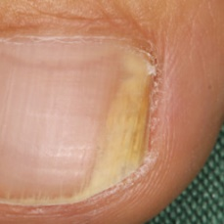fungal#514 = 0  
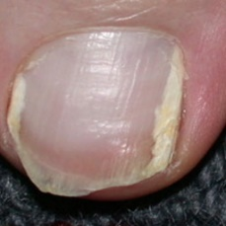fungal#0 = 0  
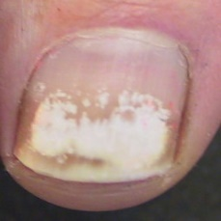fungal#89 = 0  
fungal#335 = 0  
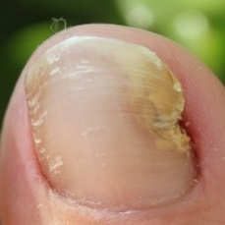fungal#498 = 0  
fungal#534 = 0  
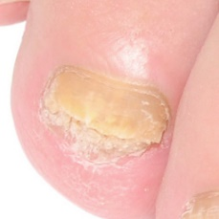fungal#421 = 0  
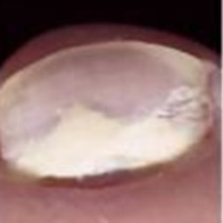fungal#477 = 0  
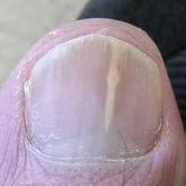fungal#499 = 0  
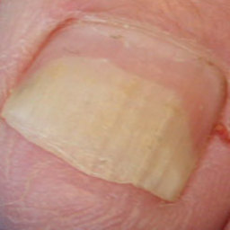fungal#28 = 0  
fungal#237 = 0  
fungal#292 = 0  
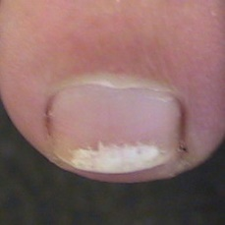fungal#90 = 0  
fungal#336 = 0  
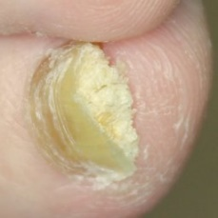fungal#362 = 0  
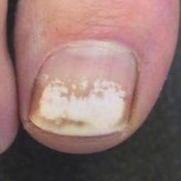fungal#204 = 0  
fungal#466 = 0  
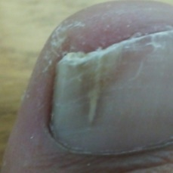fungal#525 = 0  
fungal#548 = 0  
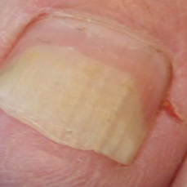fungal#435 = 0  
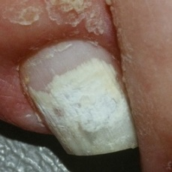fungal#141 = 0  
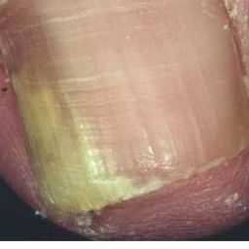fungal#30 = 0  
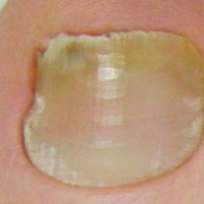fungal#409 = 0  
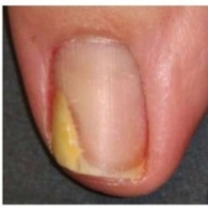fungal#230 = 0  
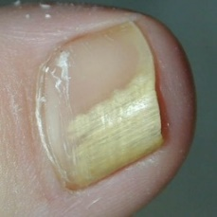fungal#140 = 0  
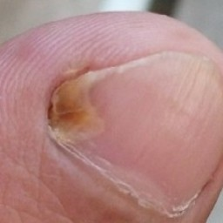fungal#542 = 0  
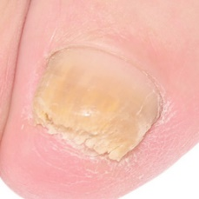fungal#422 = 0  
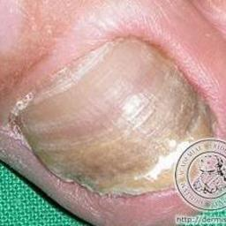fungal#160 = 0  
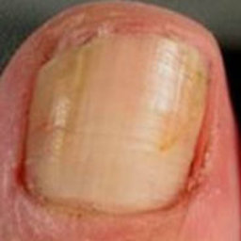fungal#64 = 0  
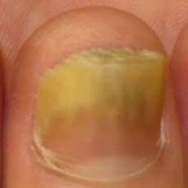fungal#551 = 0  
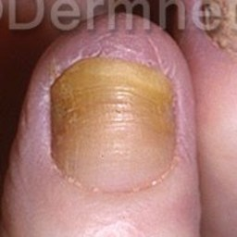fungal#248 = 0  
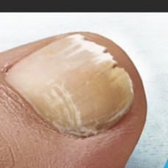fungal#449 = 0  
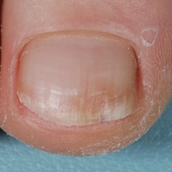fungal#527 = 0  
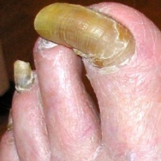fungal#182 = 0  
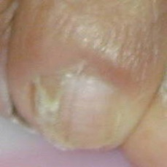fungal#166 = 0  
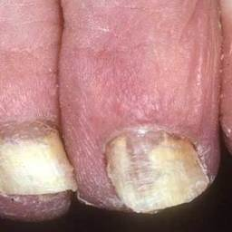fungal#458 = 0  
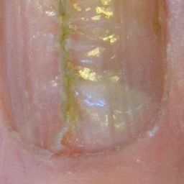fungal#468 = 0  
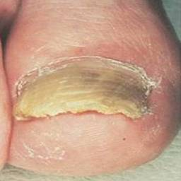fungal#209 = 0  
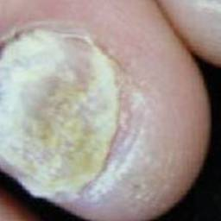fungal#361 = 0.0001  
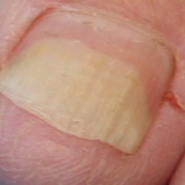fungal#258 = 0.0001  
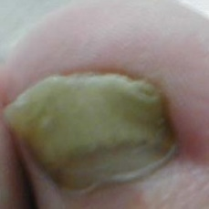fungal#469 = 0.0001  
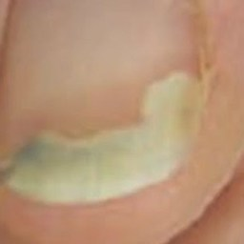fungal#611 = 0.0001  
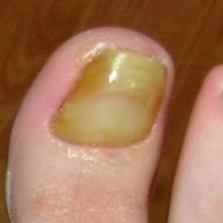fungal#114 = 0.0001  
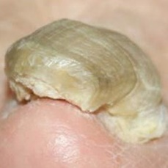fungal#32 = 0.0001  
fungal#296 = 0.0001  
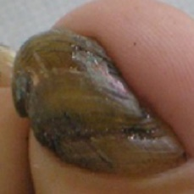fungal#309 = 0.0001  
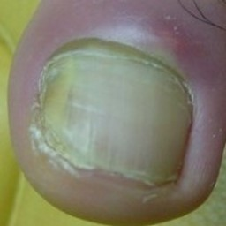fungal#606 = 0.0001  
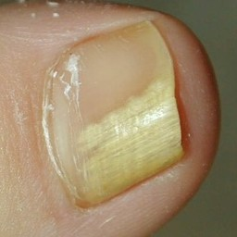fungal#5 = 0.0001  
fungal#27 = 0.0001  
fungal#291 = 0.0001  
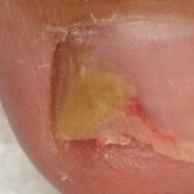fungal#103 = 0.0001  
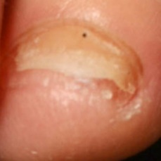fungal#207 = 0.0001  
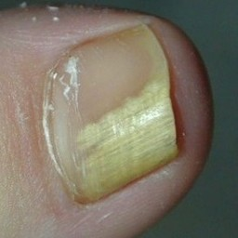fungal#372 = 0.0001  
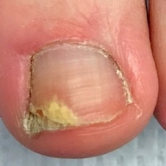fungal#179 = 0.0001  
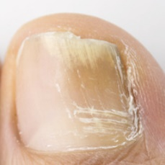fungal#617 = 0.0001  
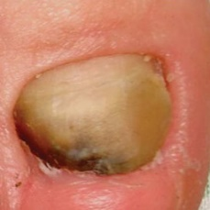fungal#430 = 0.0001  
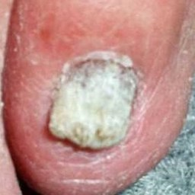fungal#319 = 0.0001  
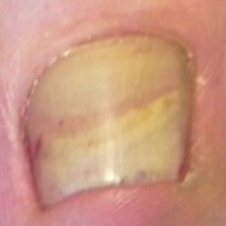fungal#314 = 0.0001  
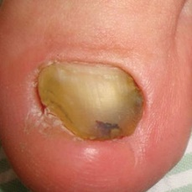fungal#429 = 0.0001  
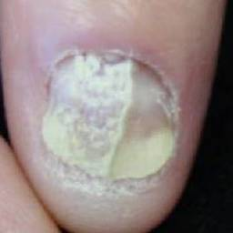fungal#360 = 0.0001  
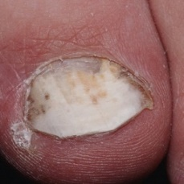fungal#186 = 0.0001  
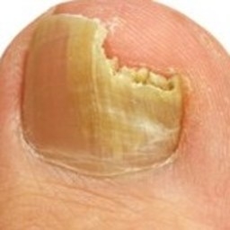fungal#452 = 0.0001  
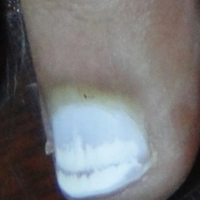fungal#250 = 0.0002  
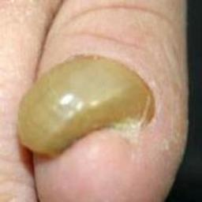fungal#609 = 0.0002  
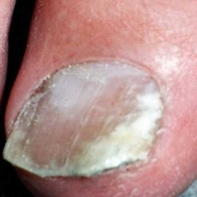fungal#55 = 0.0002  
fungal#366 = 0.0002  
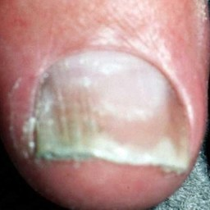fungal#317 = 0.0002  
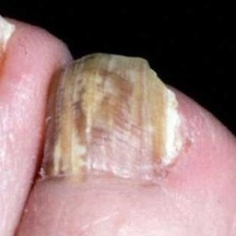fungal#396 = 0.0002  
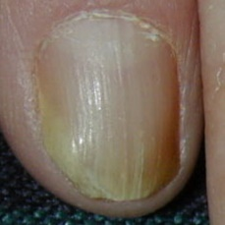fungal#15 = 0.0002  
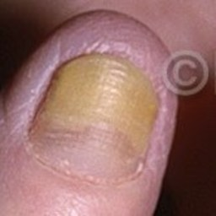fungal#247 = 0.0002  
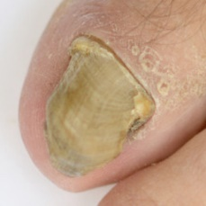fungal#163 = 0.0002  
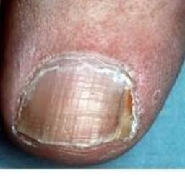fungal#48 = 0.0002  
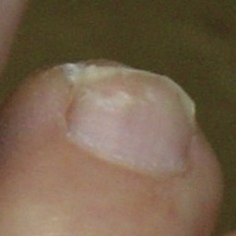fungal#22 = 0.0002  
fungal#235 = 0.0002  
fungal#288 = 0.0002  
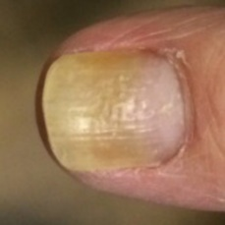fungal#380 = 0.0002  
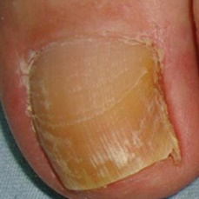fungal#446 = 0.0002  
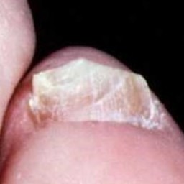fungal#395 = 0.0002  
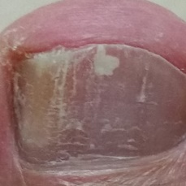fungal#511 = 0.0003  
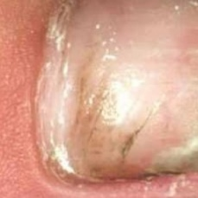fungal#425 = 0.0003  
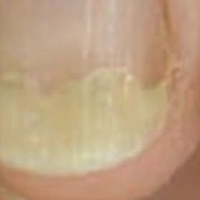fungal#612 = 0.0003  
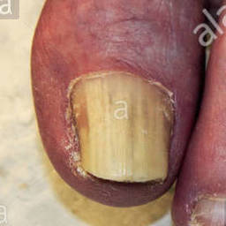fungal#242 = 0.0003  
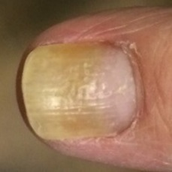fungal#276 = 0.0003  
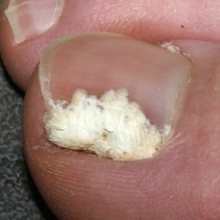fungal#192 = 0.0003  
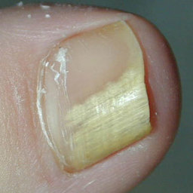fungal#399 = 0.0003  
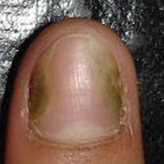fungal#143 = 0.0003  
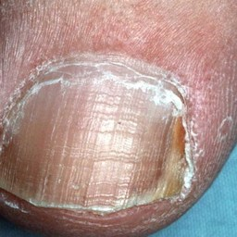fungal#405 = 0.0004  
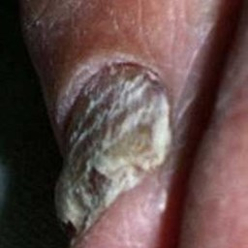fungal#57 = 0.0004  
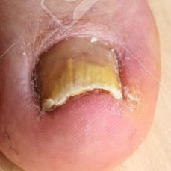fungal#73 = 0.0004  
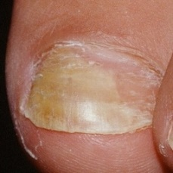fungal#21 = 0.0004  
fungal#287 = 0.0004  
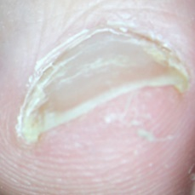fungal#159 = 0.0004  
fungal#414 = 0.0004  
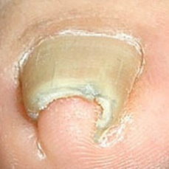fungal#7 = 0.0004  
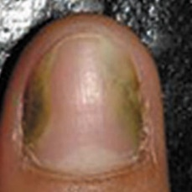fungal#246 = 0.0004  
fungal#379 = 0.0004  
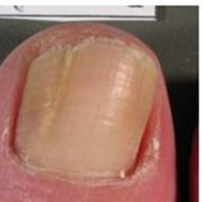fungal#65 = 0.0004  
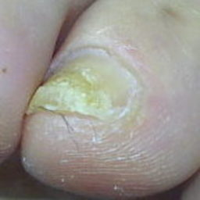fungal#502 = 0.0005  
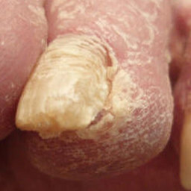fungal#375 = 0.0005  
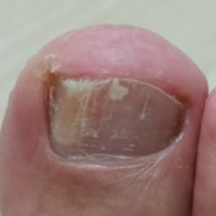fungal#518 = 0.0005  
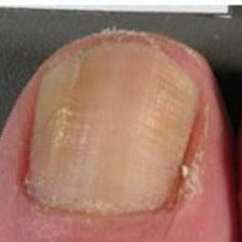fungal#67 = 0.0005  
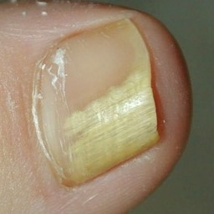fungal#189 = 0.0005  
fungal#438 = 0.0005  
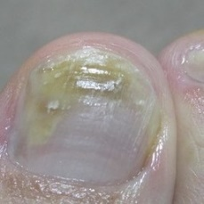fungal#549 = 0.0005  
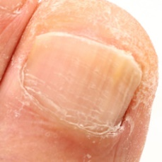fungal#462 = 0.0006  
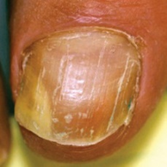fungal#205 = 0.0006  
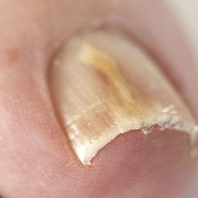fungal#150 = 0.0006  
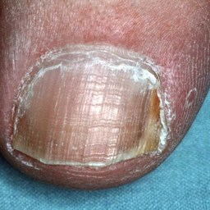fungal#273 = 0.0006  
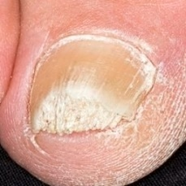fungal#92 = 0.0007  
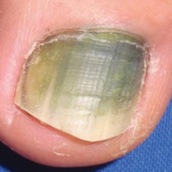fungal#343 = 0.0007  
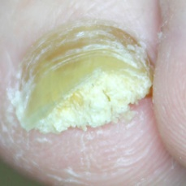fungal#158 = 0.0007  
fungal#411 = 0.0007  
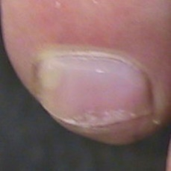fungal#91 = 0.0007  
fungal#337 = 0.0007  
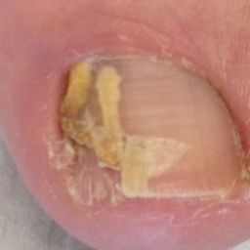fungal#95 = 0.0008  
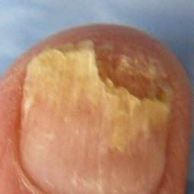fungal#131 = 0.0008  
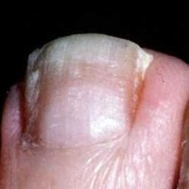fungal#394 = 0.0008  
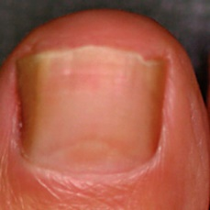fungal#168 = 0.0009  
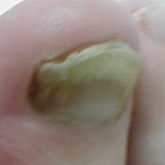fungal#474 = 0.0009  
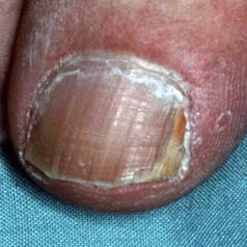fungal#6 = 0.0009  
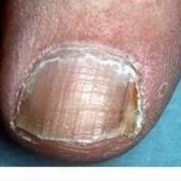fungal#198 = 0.001  
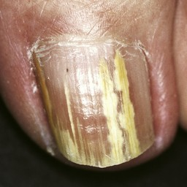fungal#341 = 0.001  
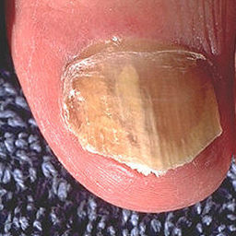fungal#72 = 0.001  
fungal#76 = 0.001  
fungal#300 = 0.001  
fungal#509 = 0.001  
fungal#605 = 0.001  
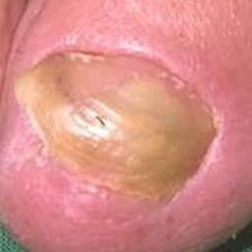fungal#117 = 0.0011  
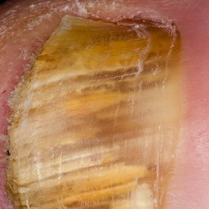fungal#84 = 0.0012  
fungal#322 = 0.0012  
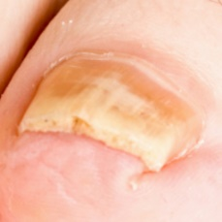fungal#310 = 0.0014  
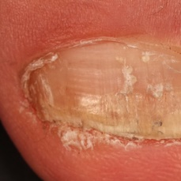fungal#345 = 0.0014  
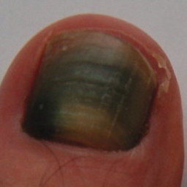fungal#426 = 0.0014  
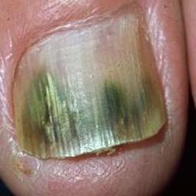fungal#505 = 0.0015  
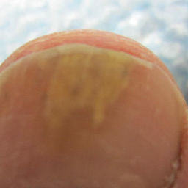fungal#540 = 0.0016  
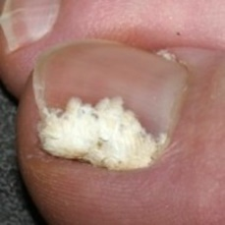fungal#444 = 0.0017  
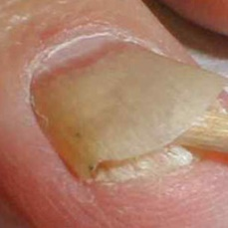fungal#77 = 0.0017  
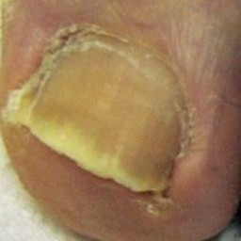fungal#320 = 0.0018  
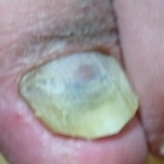fungal#497 = 0.0018  
fungal#522 = 0.0018  
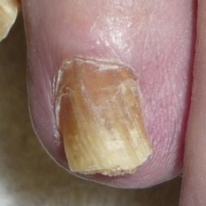fungal#278 = 0.0018  
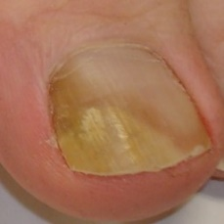fungal#389 = 0.0019  
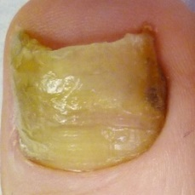fungal#410 = 0.0019  
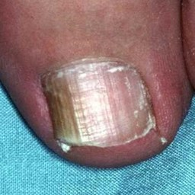fungal#400 = 0.002  
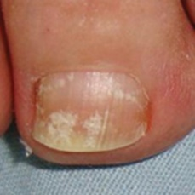fungal#447 = 0.002  
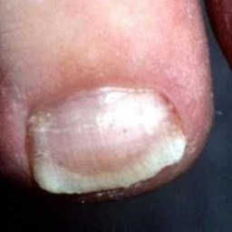fungal#153 = 0.0021  
fungal#165 = 0.0021  
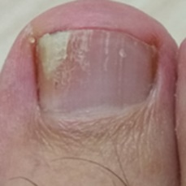fungal#526 = 0.0021  
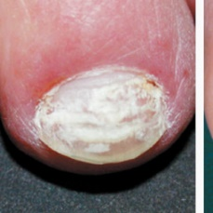fungal#581 = 0.0023  
fungal#624 = 0.0023  
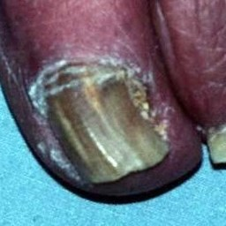fungal#416 = 0.0023  
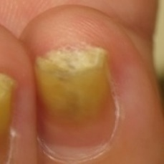fungal#553 = 0.0025  
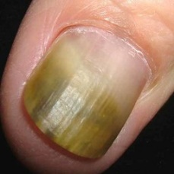fungal#16 = 0.0026  
fungal#43 = 0.0026  
fungal#282 = 0.0026  
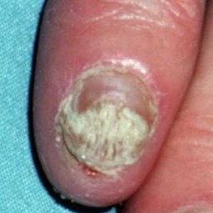fungal#11 = 0.0028  
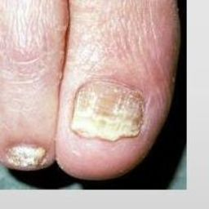fungal#373 = 0.0028  
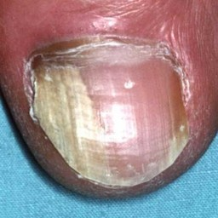fungal#128 = 0.0032  
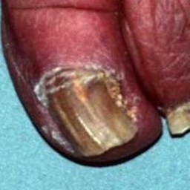fungal#297 = 0.0037  
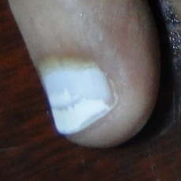fungal#252 = 0.0038  
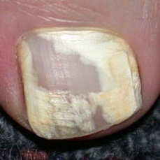fungal#1 = 0.0041  
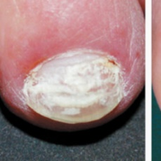fungal#588 = 0.0042  
fungal#629 = 0.0042  
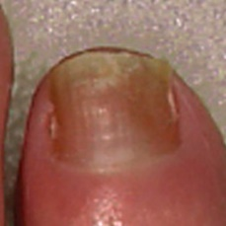fungal#172 = 0.0043  
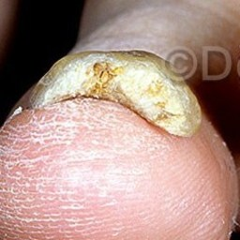fungal#136 = 0.0047  
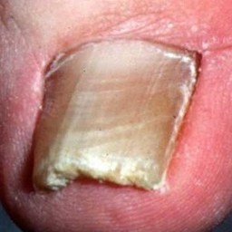fungal#152 = 0.0048  
fungal#162 = 0.0048  
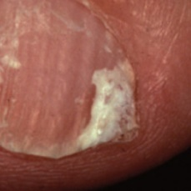fungal#378 = 0.0051  
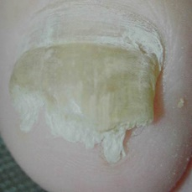fungal#535 = 0.0055  
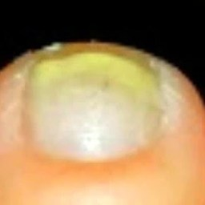fungal#531 = 0.006  
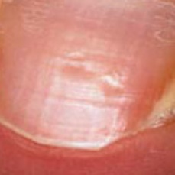fungal#139 = 0.0062  
fungal#532 = 0.0062  
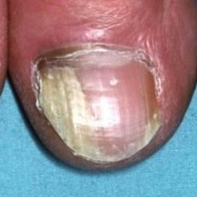fungal#324 = 0.0064  
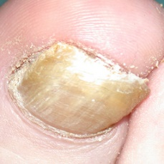fungal#197 = 0.0068  
fungal#486 = 0.0068  
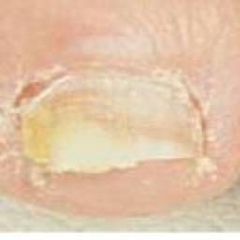fungal#210 = 0.0068  
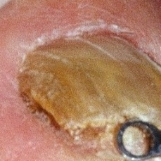fungal#334 = 0.0068  
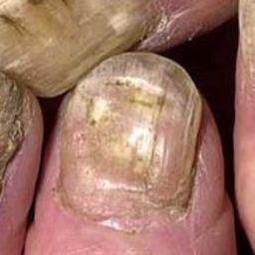fungal#68 = 0.0075  
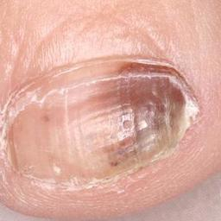fungal#508 = 0.0077  
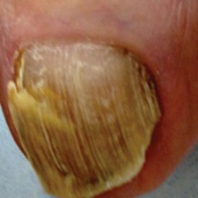fungal#74 = 0.0079  
fungal#233 = 0.0079  
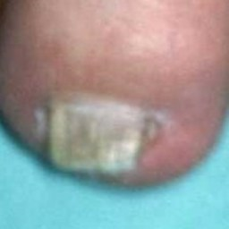fungal#481 = 0.0084  
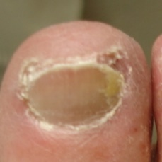fungal#557 = 0.0085  
fungal#561 = 0.0085  
fungal#572 = 0.0085  
fungal#604 = 0.0085  
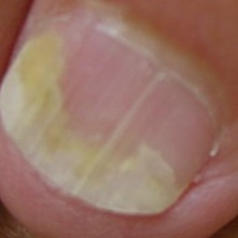fungal#40 = 0.0088  
fungal#305 = 0.0088  
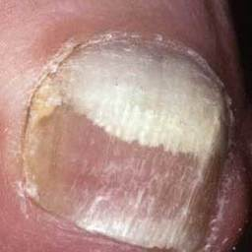fungal#454 = 0.0095  
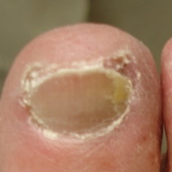fungal#554 = 0.0098  
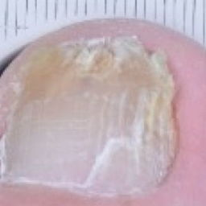fungal#427 = 0.0099  
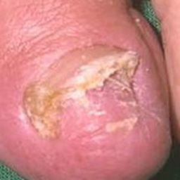fungal#116 = 0.0105  
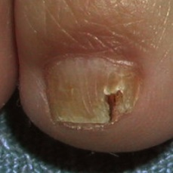fungal#81 = 0.011  
fungal#311 = 0.011  
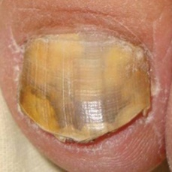fungal#439 = 0.0122  
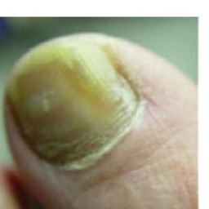fungal#224 = 0.0131  
fungal#359 = 0.0131  
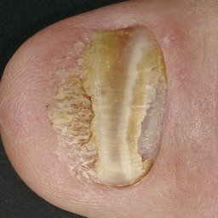fungal#377 = 0.0133  
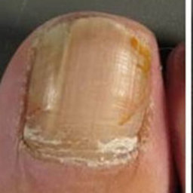fungal#66 = 0.0134  
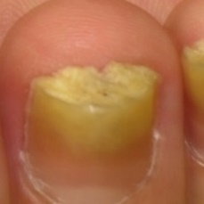fungal#552 = 0.0158  
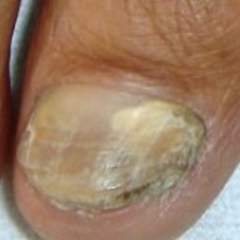fungal#25 = 0.017  
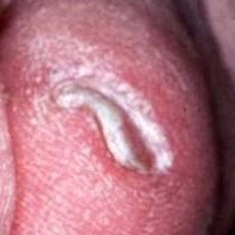fungal#2 = 0.0171  
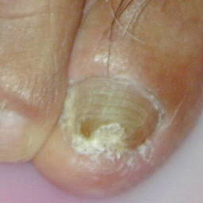fungal#167 = 0.0177  
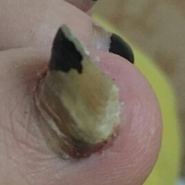fungal#590 = 0.0185  
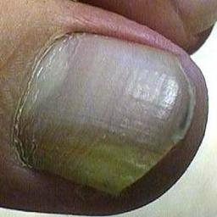fungal#285 = 0.0191  
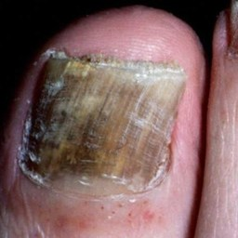fungal#392 = 0.0192  
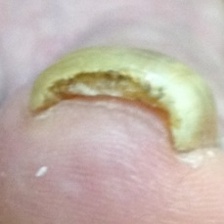fungal#461 = 0.0196  
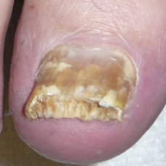fungal#244 = 0.0222  
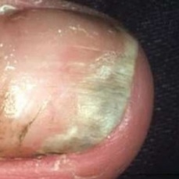fungal#424 = 0.0223  
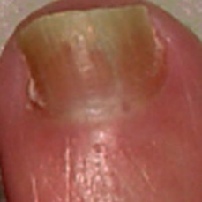fungal#173 = 0.0251  
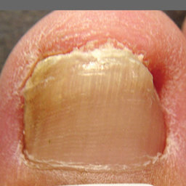fungal#358 = 0.0263  
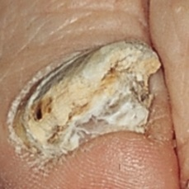fungal#83 = 0.0265  
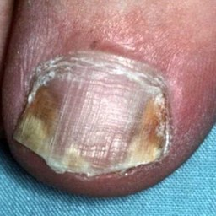fungal#277 = 0.0272  
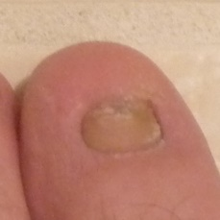fungal#326 = 0.0274  
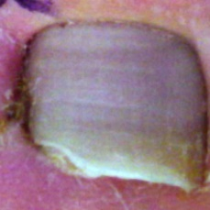fungal#329 = 0.0274  
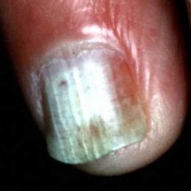fungal#41 = 0.028  
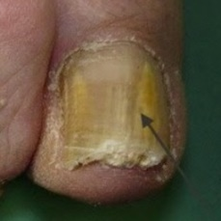fungal#234 = 0.0285  
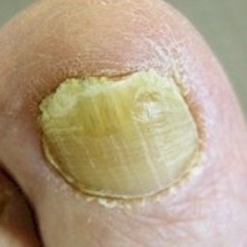fungal#333 = 0.0297  
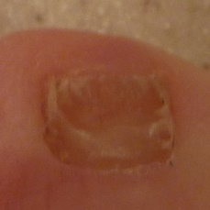fungal#417 = 0.0314  
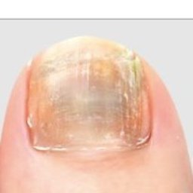fungal#496 = 0.0333  
fungal#519 = 0.0333  
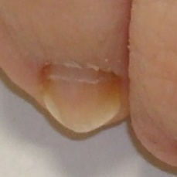fungal#390 = 0.0335  
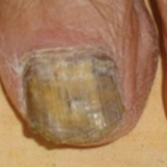fungal#441 = 0.0341  
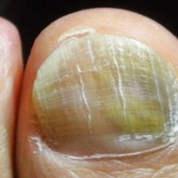fungal#593 = 0.0402  
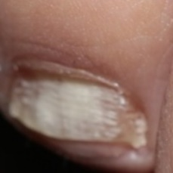fungal#145 = 0.0405  
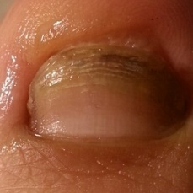fungal#591 = 0.0432  
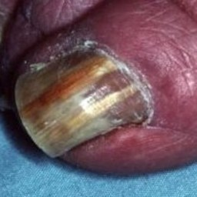fungal#4 = 0.0437  
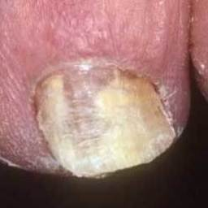fungal#456 = 0.0455  
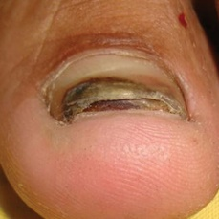fungal#19 = 0.0457  
fungal#307 = 0.0457  
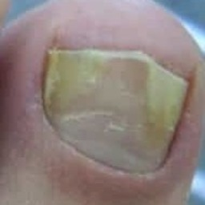fungal#381 = 0.0485  
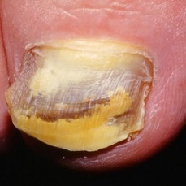fungal#151 = 0.0494  
fungal#254 = 0.0494  
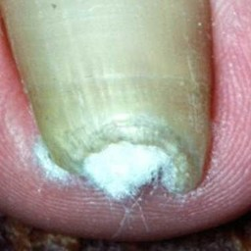fungal#437 = 0.0498  
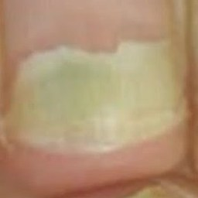fungal#610 = 0.0506  
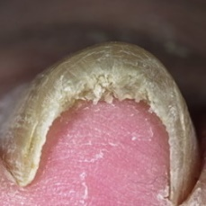fungal#448 = 0.051  
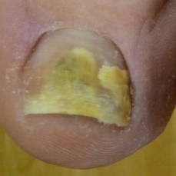fungal#87 = 0.0607  
fungal#328 = 0.0607  
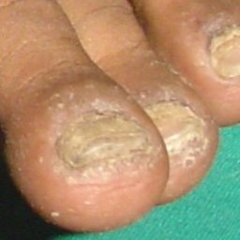fungal#376 = 0.0627  
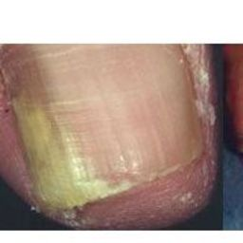fungal#220 = 0.0675  
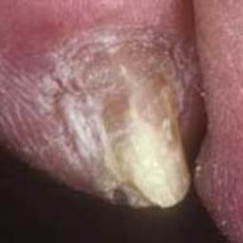fungal#457 = 0.0755  
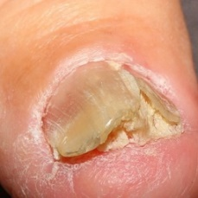fungal#35 = 0.0757  
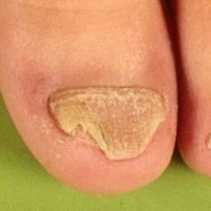fungal#12 = 0.0769  
fungal#274 = 0.0769  
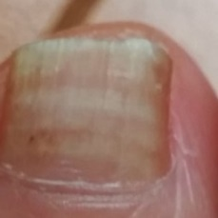fungal#521 = 0.0773  
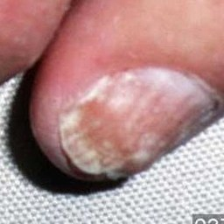fungal#58 = 0.0837  
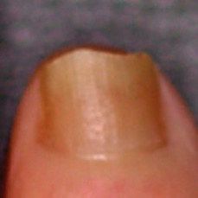fungal#170 = 0.0859  
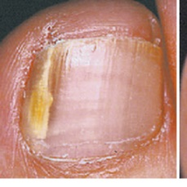fungal#529 = 0.0866  
fungal#96 = 0.0877  
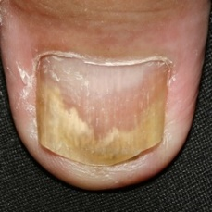fungal#29 = 0.088  
fungal#61 = 0.088  
fungal#293 = 0.088  
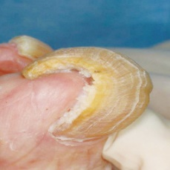fungal#550 = 0.088  
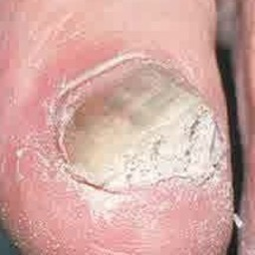fungal#69 = 0.0971  
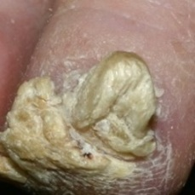fungal#451 = 0.0974  
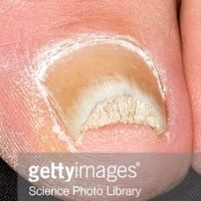fungal#93 = 0.0974  
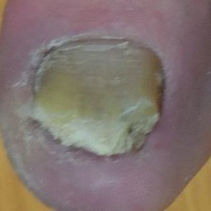fungal#106 = 0.0984  
fungal#349 = 0.0984  
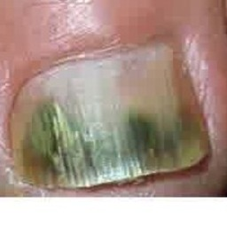fungal#70 = 0.1044  
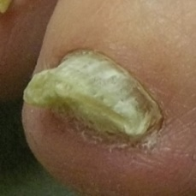fungal#24 = 0.1055  
fungal#290 = 0.1055  
fungal#332 = 0.1055  
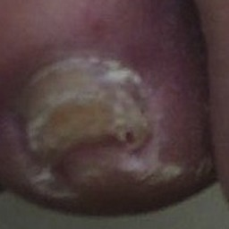fungal#268 = 0.1059  
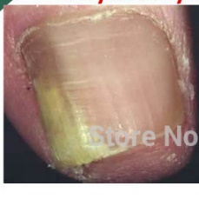fungal#222 = 0.1088  
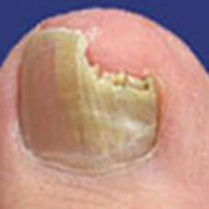fungal#217 = 0.1113  
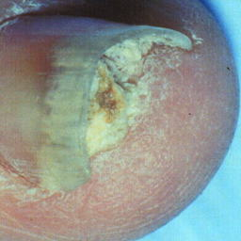fungal#369 = 0.1136  
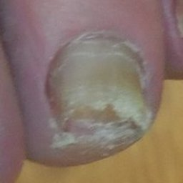fungal#109 = 0.1152  
fungal#352 = 0.1152  
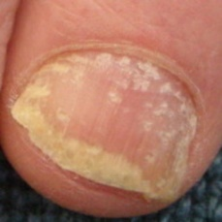fungal#261 = 0.122  
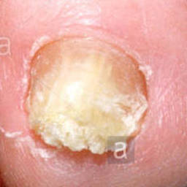fungal#50 = 0.1274  
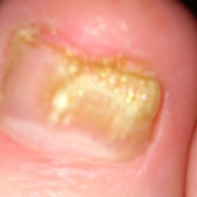fungal#453 = 0.1308  
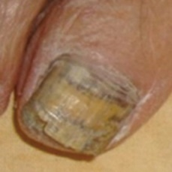fungal#442 = 0.1377  
normal#24 = 0.1476  
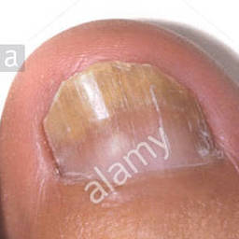fungal#113 = 0.149  
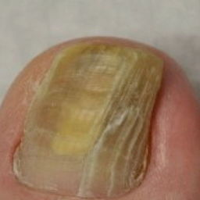fungal#428 = 0.1492  
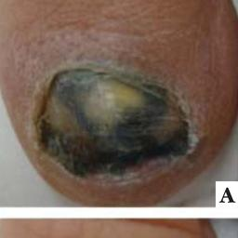fungal#101 = 0.1506  
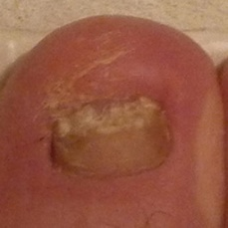fungal#3 = 0.1557  
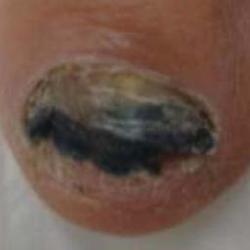fungal#100 = 0.1625  
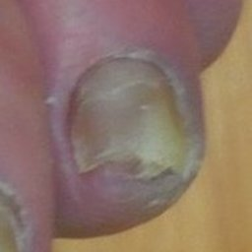fungal#108 = 0.165  
fungal#351 = 0.165  
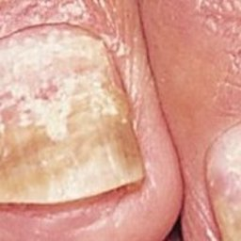fungal#18 = 0.1696  
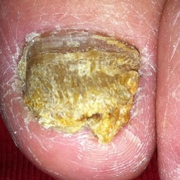fungal#472 = 0.1705  
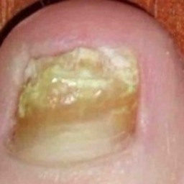fungal#607 = 0.1877  
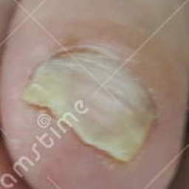fungal#102 = 0.1955  
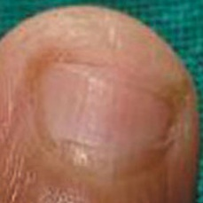fungal#266 = 0.1962  
fungal#479 = 0.1962  
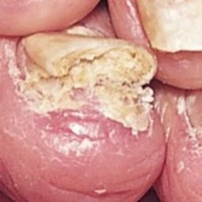fungal#17 = 0.2021  
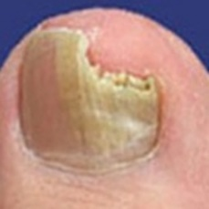fungal#245 = 0.2153  
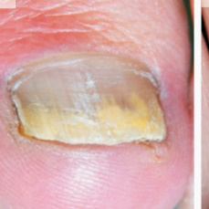fungal#587 = 0.2205  
fungal#628 = 0.2205  
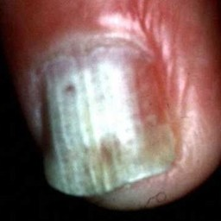fungal#490 = 0.2273  
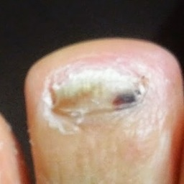fungal#594 = 0.229  
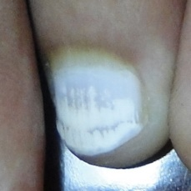fungal#251 = 0.2518  
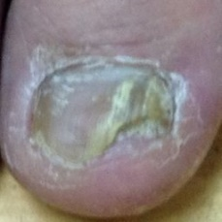fungal#478 = 0.2563  
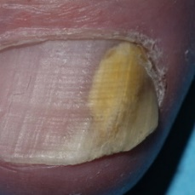fungal#206 = 0.2616  
fungal#354 = 0.2616  
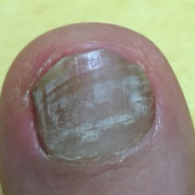fungal#589 = 0.2781  
fungal#592 = 0.2781  
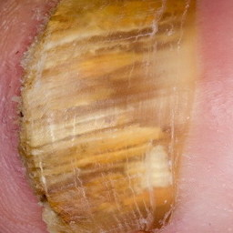fungal#85 = 0.3318  
fungal#323 = 0.3318  
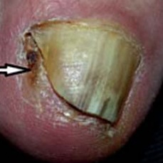fungal#20 = 0.3578  
fungal#286 = 0.3578  
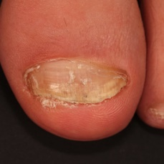fungal#344 = 0.3632  
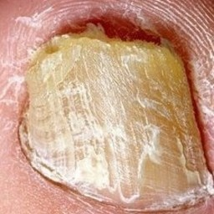fungal#528 = 0.3634  
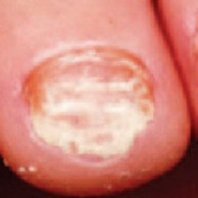fungal#133 = 0.3701  
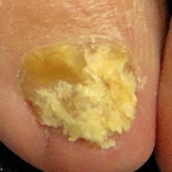fungal#56 = 0.4084  
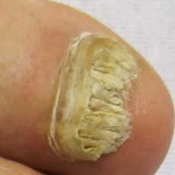fungal#465 = 0.4163  
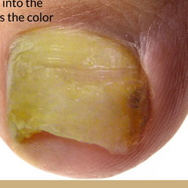fungal#120 = 0.4246  
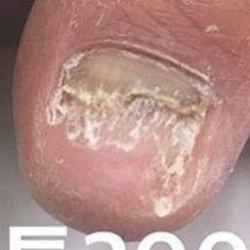fungal#576 = 0.4272  
fungal#622 = 0.4272  
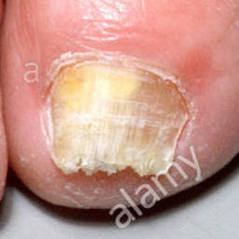fungal#49 = 0.4456  
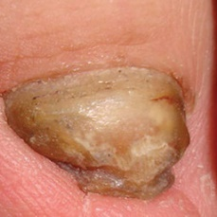fungal#431 = 0.4572  
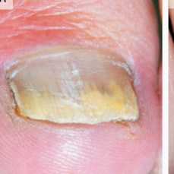fungal#582 = 0.4601  
fungal#625 = 0.4601  
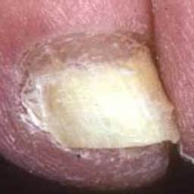fungal#455 = 0.4638  
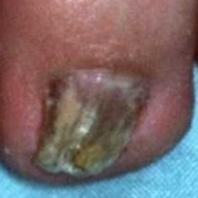fungal#213 = 0.4845  
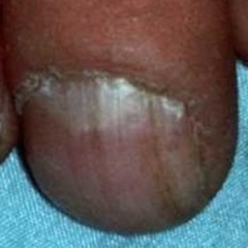fungal#412 = 0.4875  
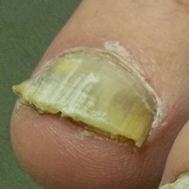fungal#23 = 0.4918  
fungal#289 = 0.4918  
fungal#331 = 0.4918  
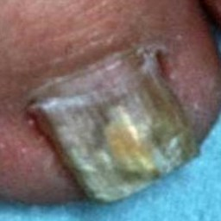fungal#175 = 0.4933  
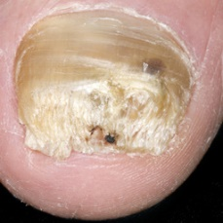fungal#127 = 0.4935  
fungal#364 = 0.4935  
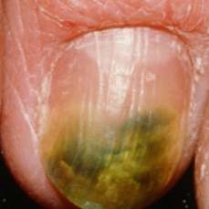fungal#616 = 0.4957  
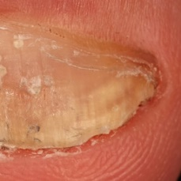fungal#346 = 0.5178  
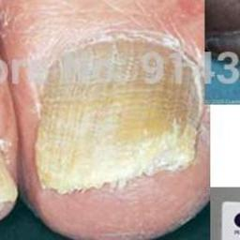fungal#47 = 0.5466  
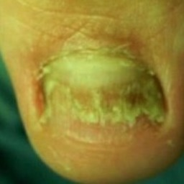fungal#562 = 0.5511  
fungal#578 = 0.5511  
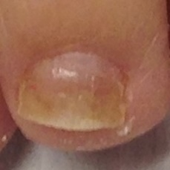fungal#98 = 0.553  
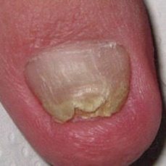fungal#265 = 0.5673  
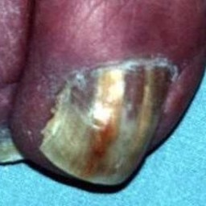fungal#415 = 0.5857  
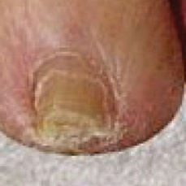fungal#123 = 0.5978  
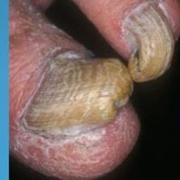fungal#231 = 0.6045  
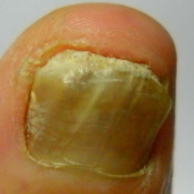fungal#570 = 0.605  
fungal#602 = 0.605  
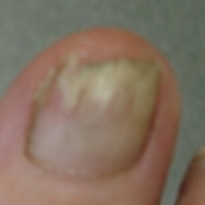fungal#569 = 0.6153  
fungal#630 = 0.6153  
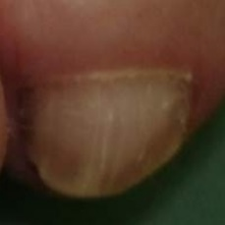fungal#257 = 0.6208  
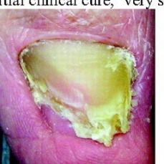fungal#228 = 0.6208  
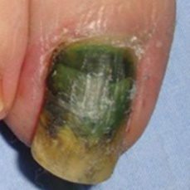fungal#342 = 0.6277  
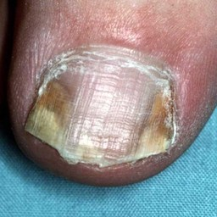fungal#374 = 0.6338  
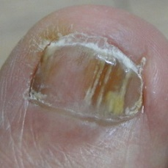fungal#585 = 0.6339  
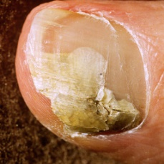fungal#321 = 0.6994  
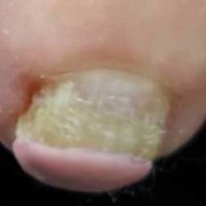fungal#598 = 0.7066  
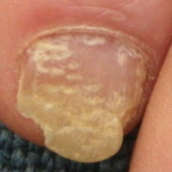fungal#262 = 0.7156  
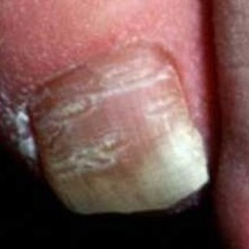fungal#156 = 0.7159  
fungal#180 = 0.7159  
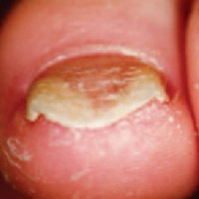fungal#132 = 0.7168  
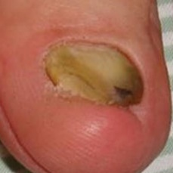fungal#432 = 0.7659  
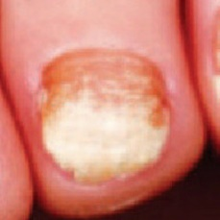fungal#135 = 0.7752  
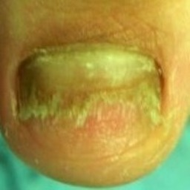fungal#563 = 0.7817  
fungal#579 = 0.7817  
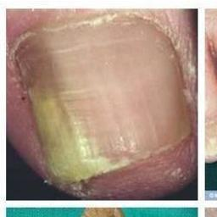fungal#199 = 0.7896  
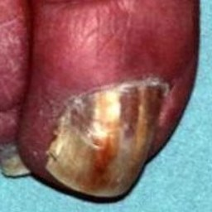fungal#295 = 0.8017  
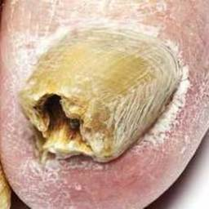fungal#10 = 0.8084  
fungal#216 = 0.8084  
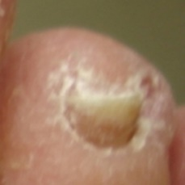fungal#556 = 0.8178  
fungal#559 = 0.8178  
fungal#571 = 0.8178  
fungal#603 = 0.8178  
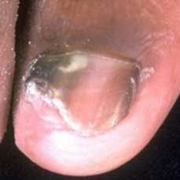fungal#164 = 0.8219  
fungal#450 = 0.8219  
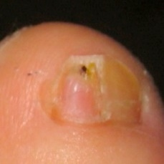fungal#44 = 0.83  
fungal#339 = 0.83  
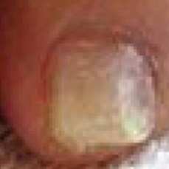fungal#122 = 0.8314  
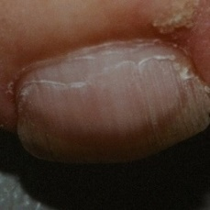fungal#142 = 0.8353  
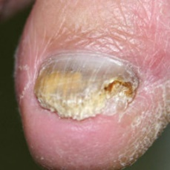fungal#495 = 0.8465  
fungal#512 = 0.8465  
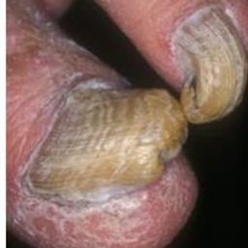fungal#219 = 0.8527  
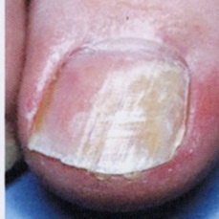fungal#566 = 0.8545  
fungal#626 = 0.8545  
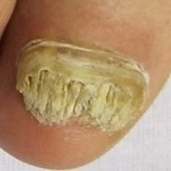fungal#118 = 0.8596  
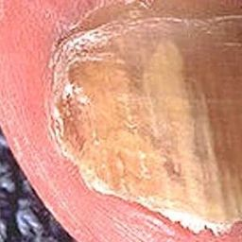fungal#130 = 0.8669  
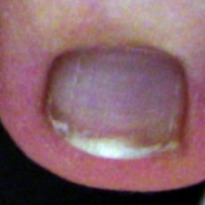fungal#327 = 0.8685  
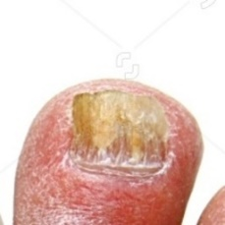fungal#94 = 0.8758  
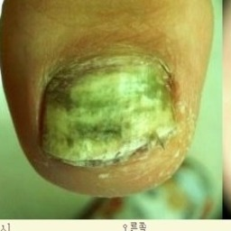fungal#560 = 0.8765  
fungal#577 = 0.8765  
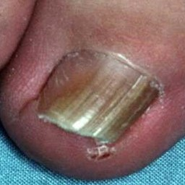fungal#401 = 0.8852  
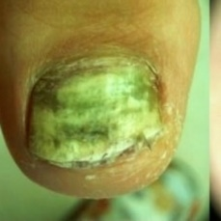fungal#608 = 0.886  
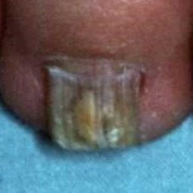fungal#214 = 0.8867  
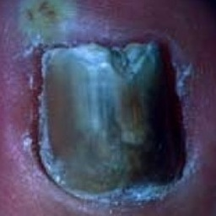fungal#38 = 0.9  
fungal#303 = 0.9  
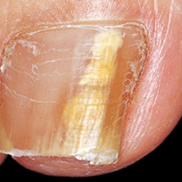fungal#503 = 0.9004  
fungal#510 = 0.9004  
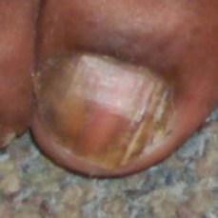fungal#196 = 0.9006  
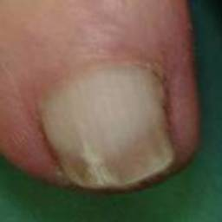fungal#483 = 0.9057  
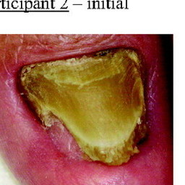fungal#227 = 0.9084  
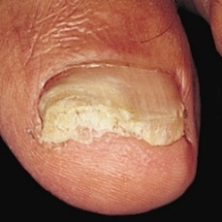fungal#148 = 0.912  
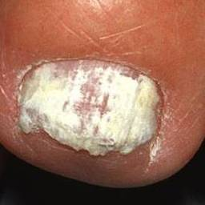fungal#471 = 0.9144  
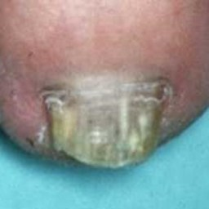fungal#480 = 0.9152  
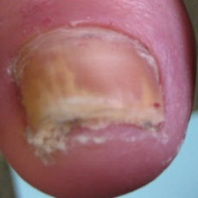fungal#53 = 0.9165  
fungal#492 = 0.9165  
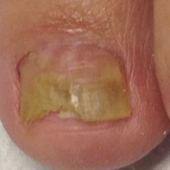fungal#97 = 0.9189  
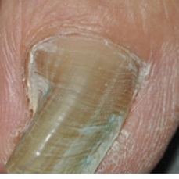fungal#620 = 0.9193  
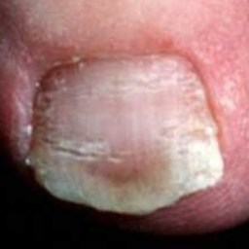fungal#154 = 0.9266  
fungal#171 = 0.9266  
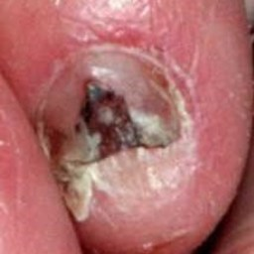fungal#241 = 0.9275  
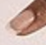normal#13 = 0.9275  
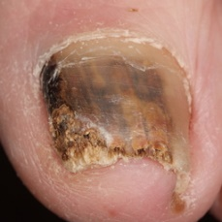fungal#161 = 0.9292  
fungal#436 = 0.9292  
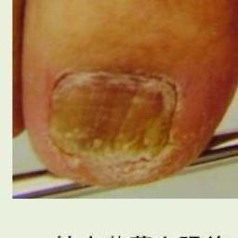fungal#501 = 0.9313  
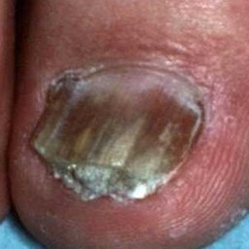fungal#211 = 0.9333  
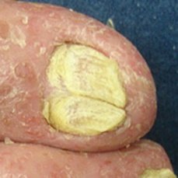fungal#613 = 0.9337  
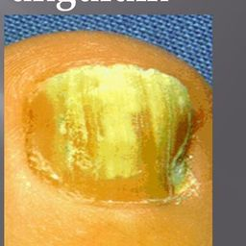fungal#115 = 0.9476  
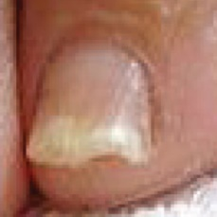fungal#121 = 0.9491  
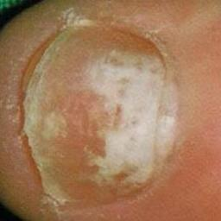fungal#338 = 0.9491  
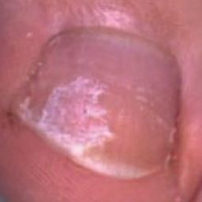fungal#71 = 0.9502  
fungal#284 = 0.9502  
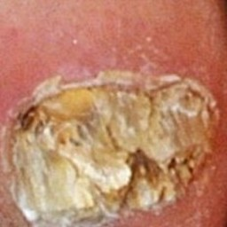fungal#75 = 0.951  
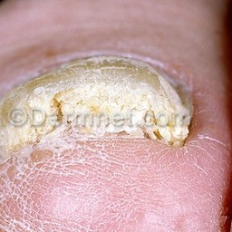fungal#45 = 0.952  
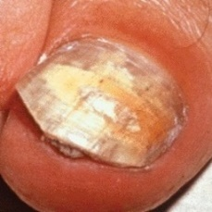fungal#200 = 0.9536  
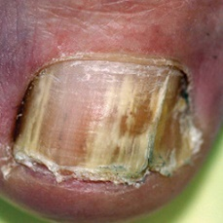fungal#239 = 0.9547  
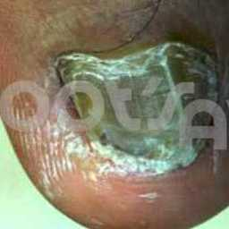fungal#586 = 0.9577  
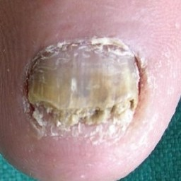fungal#203 = 0.9618  
fungal#491 = 0.9618  
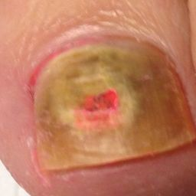fungal#62 = 0.9651  
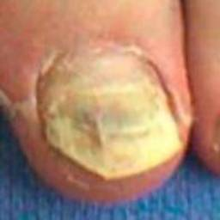fungal#42 = 0.9657  
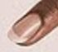normal#14 = 0.9663  
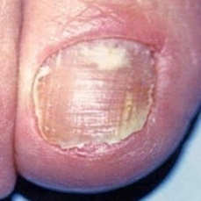fungal#181 = 0.9663  
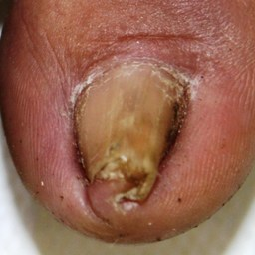fungal#269 = 0.9681  
fungal#384 = 0.9681  
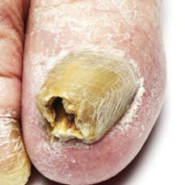fungal#190 = 0.9689  
fungal#433 = 0.9689  
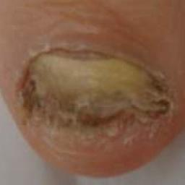fungal#99 = 0.9706  
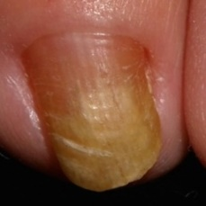fungal#63 = 0.975  
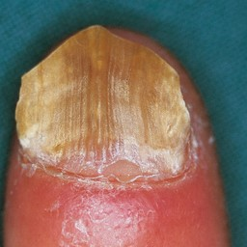fungal#147 = 0.9752  
fungal#383 = 0.9752  
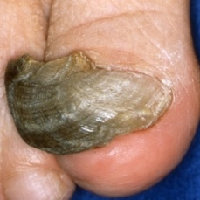fungal#506 = 0.9757  
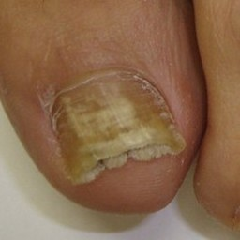fungal#475 = 0.9757  
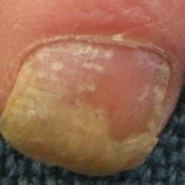fungal#260 = 0.9758  
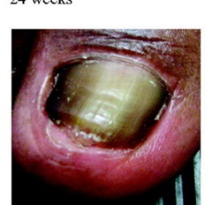fungal#225 = 0.9761  
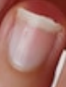normal#46 = 0.9767  
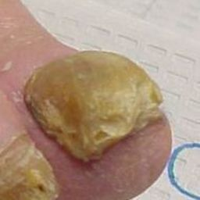fungal#467 = 0.9771  
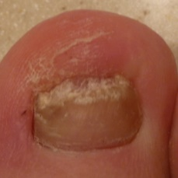fungal#418 = 0.9774  
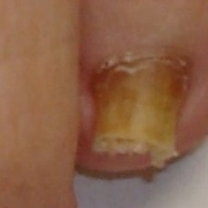fungal#391 = 0.9784  
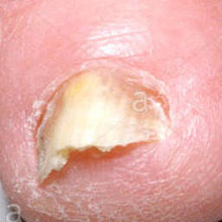fungal#52 = 0.9789  
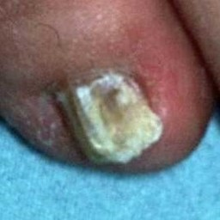fungal#176 = 0.9807  
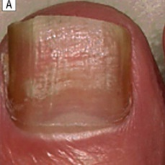fungal#169 = 0.9814  
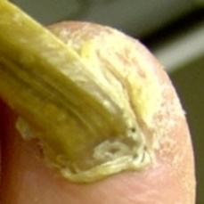fungal#340 = 0.9837  
normal#16 = 0.9861  
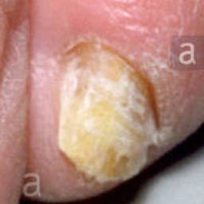fungal#51 = 0.9863  
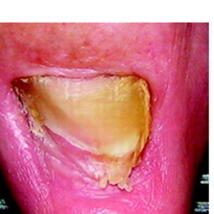fungal#229 = 0.9869  
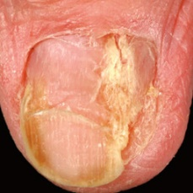fungal#259 = 0.9871  
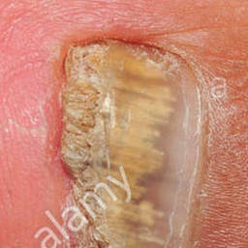fungal#185 = 0.9875  
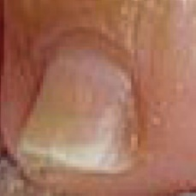fungal#126 = 0.988  
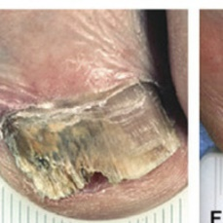fungal#34 = 0.9884  
fungal#138 = 0.9884  
fungal#299 = 0.9884  
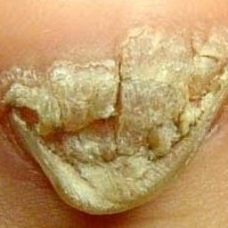fungal#8 = 0.9888  
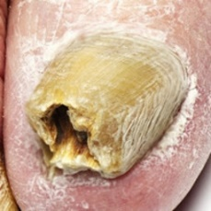fungal#623 = 0.9899  
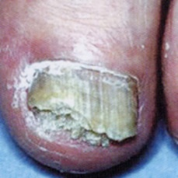fungal#567 = 0.9909  
fungal#627 = 0.9909  
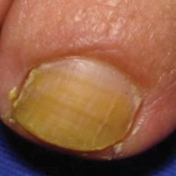fungal#397 = 0.9916  
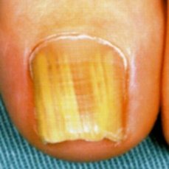fungal#564 = 0.9916  
fungal#565 = 0.9916  
fungal#614 = 0.9916  
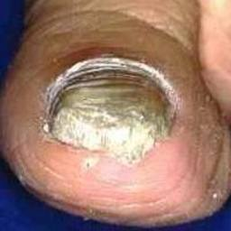fungal#263 = 0.9919  
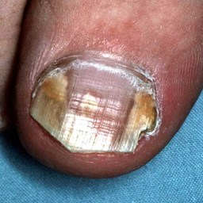fungal#387 = 0.992  
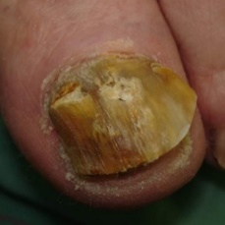fungal#256 = 0.9921  
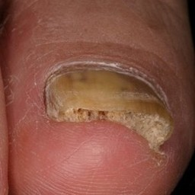fungal#516 = 0.9924  
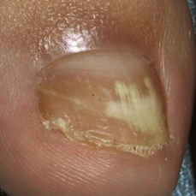fungal#79 = 0.9929  
fungal#306 = 0.9929  
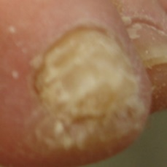fungal#601 = 0.9929  
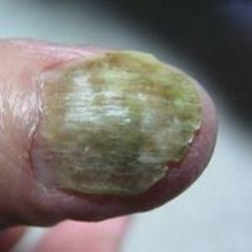fungal#539 = 0.9931  
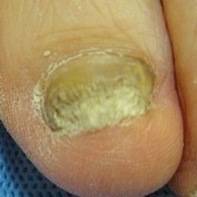fungal#584 = 0.9932  
fungal#615 = 0.9932  
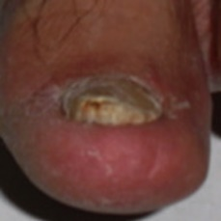fungal#183 = 0.9933  
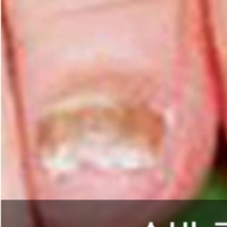fungal#574 = 0.9934  
fungal#619 = 0.9934  
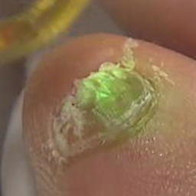fungal#555 = 0.9936  
fungal#600 = 0.9936  
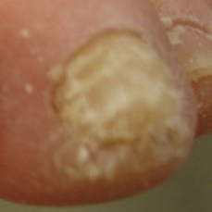fungal#558 = 0.9939  
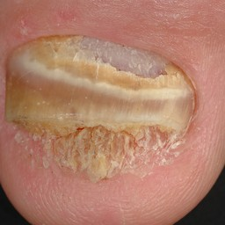fungal#476 = 0.9939  
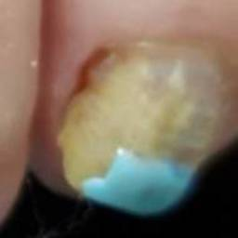fungal#599 = 0.9942  
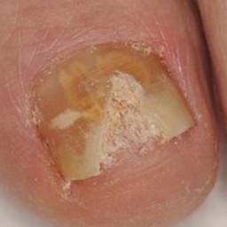fungal#371 = 0.9944  
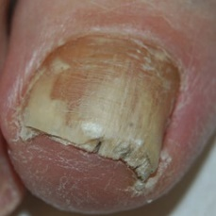fungal#201 = 0.9949  
fungal#487 = 0.9949  
normal#33 = 0.9951  
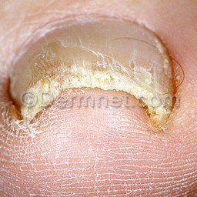fungal#191 = 0.9955  
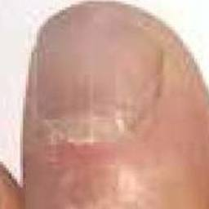fungal#249 = 0.9962  
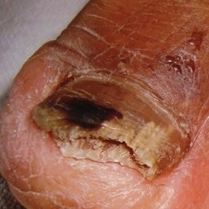fungal#9 = 0.9964  
fungal#215 = 0.9964  
fungal#281 = 0.9964  
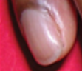normal#19 = 0.9965  
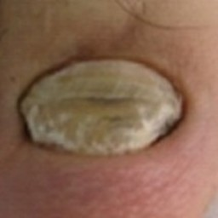fungal#357 = 0.9966  
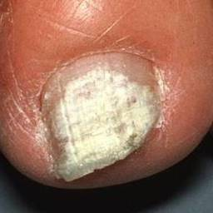fungal#470 = 0.9971  
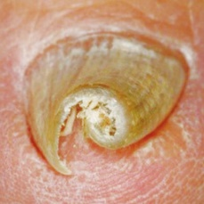fungal#493 = 0.9974  
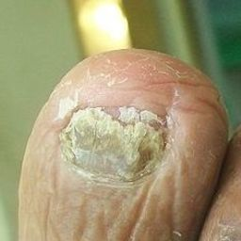fungal#370 = 0.9977  
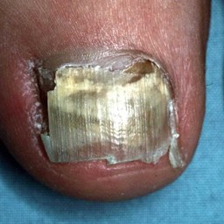fungal#355 = 0.9978  
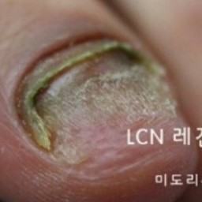fungal#595 = 0.9978  
fungal#631 = 0.9978  
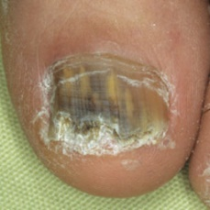fungal#520 = 0.9978  
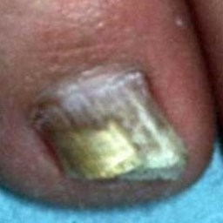fungal#177 = 0.9979  
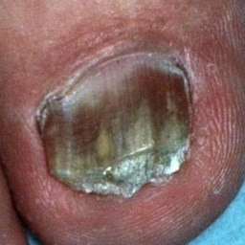fungal#174 = 0.9981  
normal#15 = 0.9982  
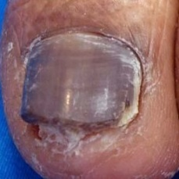fungal#280 = 0.9983  
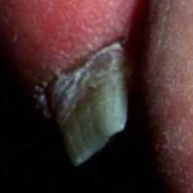fungal#157 = 0.9984  
fungal#188 = 0.9984  
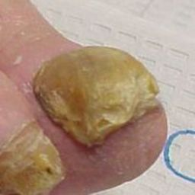fungal#105 = 0.9984  
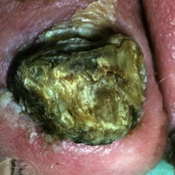fungal#459 = 0.9985  
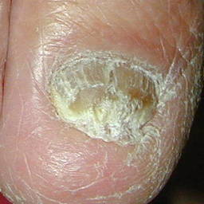fungal#46 = 0.9988  
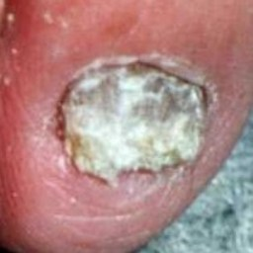fungal#318 = 0.9988  
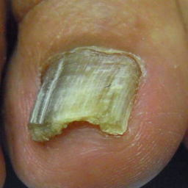fungal#541 = 0.9988  
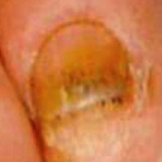fungal#434 = 0.9988  
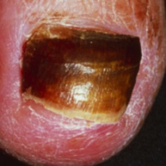fungal#272 = 0.9989  
fungal#489 = 0.9989  
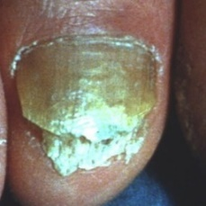fungal#264 = 0.999  
fungal#464 = 0.999  
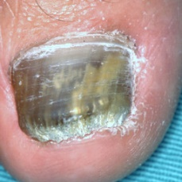fungal#538 = 0.9991  
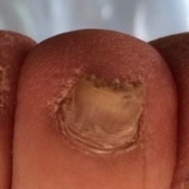fungal#255 = 0.9991  
fungal#443 = 0.9991  
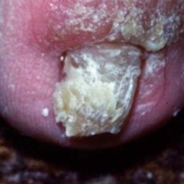fungal#195 = 0.9991  
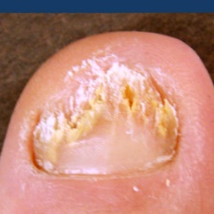fungal#155 = 0.9992  
normal#45 = 0.9992  
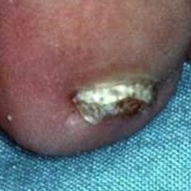fungal#403 = 0.9992  
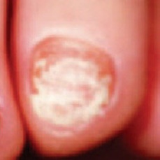fungal#134 = 0.9993  
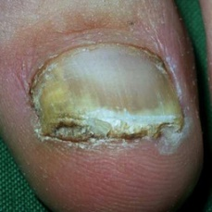fungal#202 = 0.9993  
fungal#488 = 0.9993  
normal#59 = 0.9994  
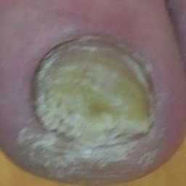fungal#107 = 0.9994  
fungal#350 = 0.9994  
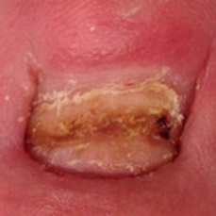fungal#26 = 0.9994  
normal#27 = 0.9994  
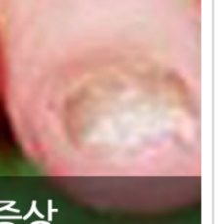fungal#573 = 0.9995  
fungal#618 = 0.9995  
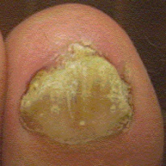fungal#149 = 0.9995  
fungal#402 = 0.9995  
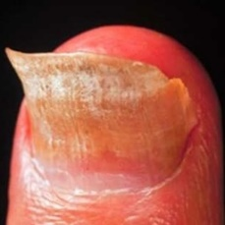fungal#253 = 0.9995  
normal#25 = 0.9996  
normal#60 = 0.9996  
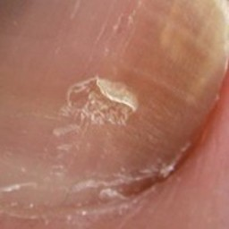fungal#14 = 0.9996  
fungal#279 = 0.9996  
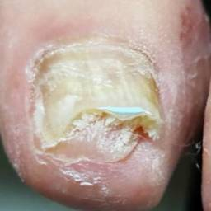fungal#597 = 0.9996  
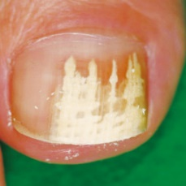fungal#494 = 0.9996  
normal#26 = 0.9996  
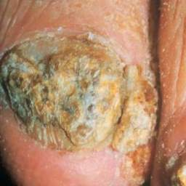fungal#60 = 0.9996  
fungal#243 = 0.9996  
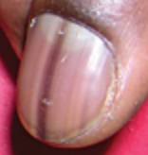normal#17 = 0.9996  
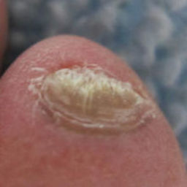fungal#544 = 0.9997  
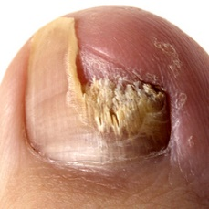fungal#406 = 0.9997  
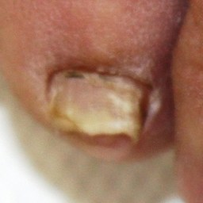fungal#270 = 0.9998  
fungal#385 = 0.9998  
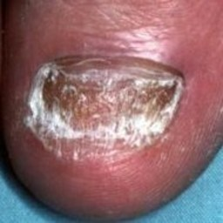fungal#325 = 0.9998  
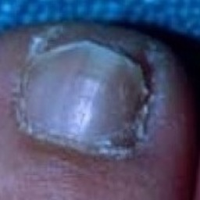fungal#39 = 0.9998  
fungal#304 = 0.9998  
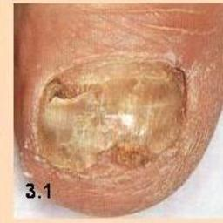fungal#413 = 0.9998  
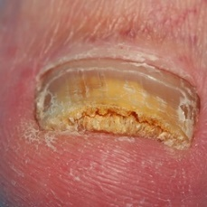fungal#388 = 0.9998  
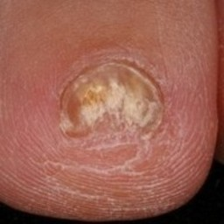fungal#515 = 0.9998  
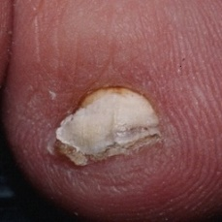fungal#187 = 0.9998  
normal#28 = 0.9998  
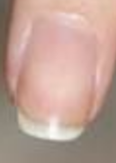normal#35 = 0.9998  
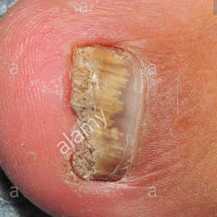fungal#184 = 0.9998  
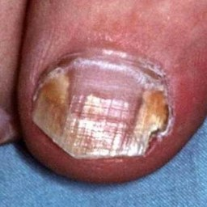fungal#193 = 0.9999  
fungal#347 = 0.9999  
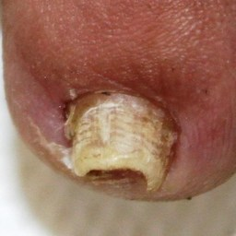fungal#271 = 0.9999  
fungal#386 = 0.9999  
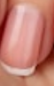normal#58 = 0.9999  
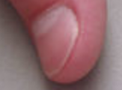normal#29 = 0.9999  
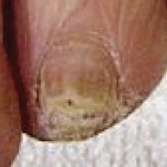fungal#125 = 0.9999  
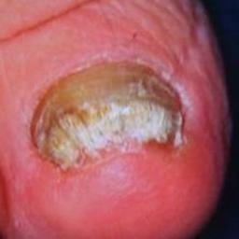fungal#500 = 0.9999  
fungal#517 = 0.9999  
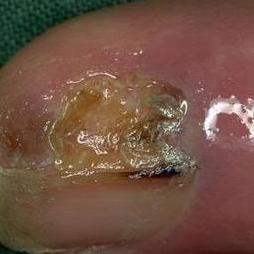fungal#504 = 0.9999  
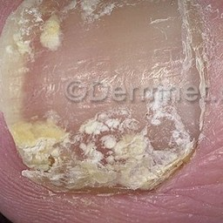fungal#112 = 0.9999  
normal#62 = 0.9999  
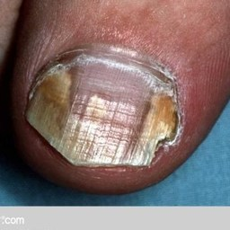fungal#330 = 0.9999  
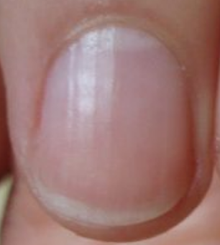normal#52 = 0.9999  
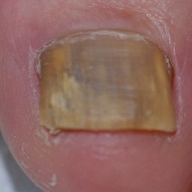fungal#463 = 0.9999  
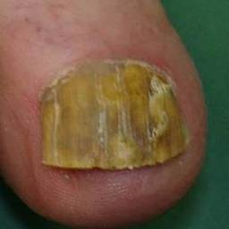fungal#482 = 0.9999  
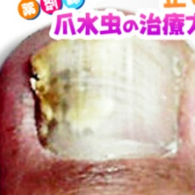fungal#507 = 0.9999  
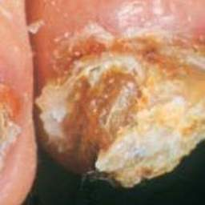fungal#59 = 0.9999  
fungal#240 = 0.9999  
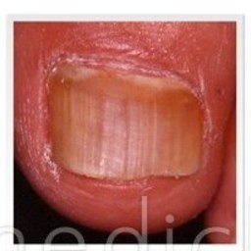fungal#536 = 0.9999  
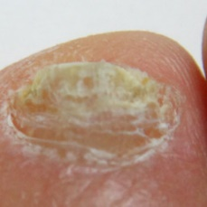fungal#575 = 0.9999  
fungal#621 = 0.9999  
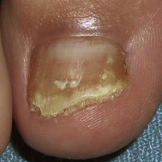fungal#80 = 1  
fungal#308 = 1  
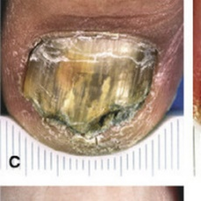fungal#33 = 1  
fungal#137 = 1  
fungal#298 = 1  
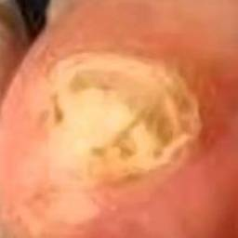fungal#208 = 1  
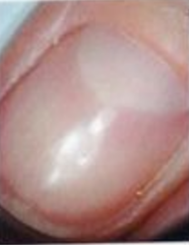normal#12 = 1  
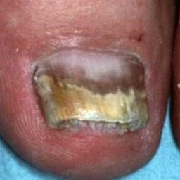fungal#212 = 1  
normal#57 = 1  
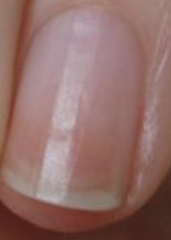normal#55 = 1  
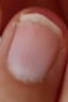normal#47 = 1  
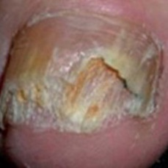fungal#445 = 1  
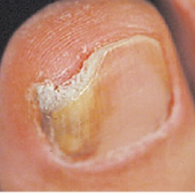fungal#530 = 1  
normal#63 = 1  
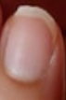normal#48 = 1  
normal#61 = 1  
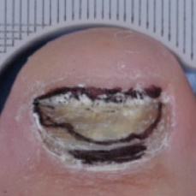fungal#533 = 1  
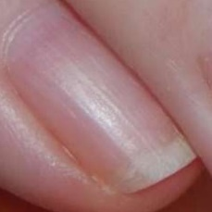normal#51 = 1  
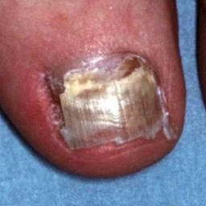fungal#194 = 1  
fungal#348 = 1  
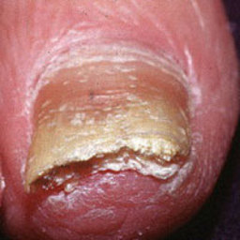fungal#110 = 1  
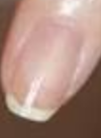normal#36 = 1  
normal#37 = 1  
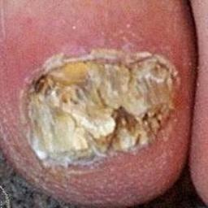fungal#223 = 1  
normal#23 = 1  
normal#56 = 1  
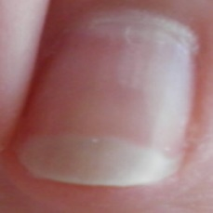normal#7 = 1  
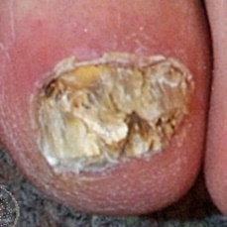fungal#312 = 1  
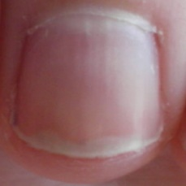normal#6 = 1  
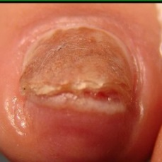fungal#404 = 1  
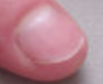normal#30 = 1  
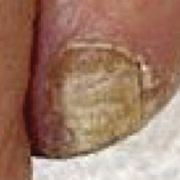fungal#124 = 1  
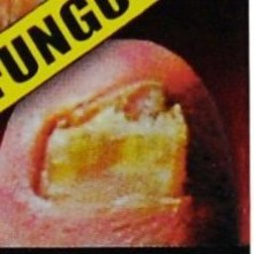fungal#221 = 1  
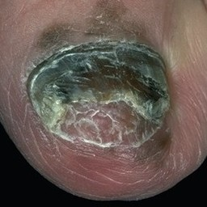fungal#356 = 1  
normal#22 = 1  
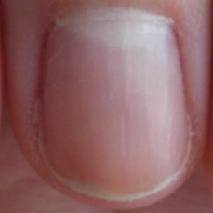normal#5 = 1  
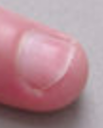normal#32 = 1  
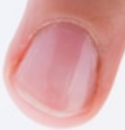normal#42 = 1  
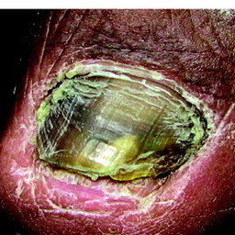fungal#226 = 1  
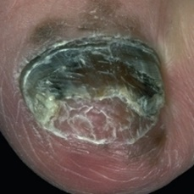fungal#473 = 1  
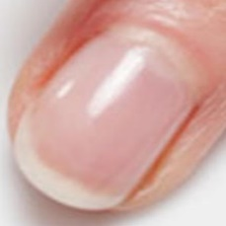normal#1 = 1  
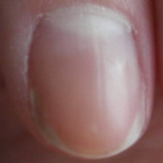normal#4 = 1  
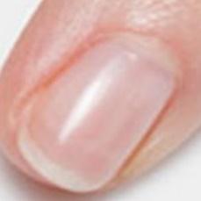normal#11 = 1  
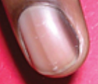normal#18 = 1  
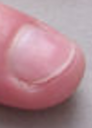normal#31 = 1  
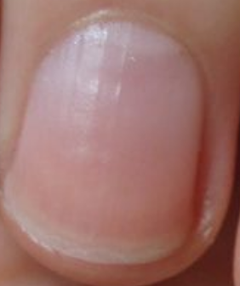normal#53 = 1  
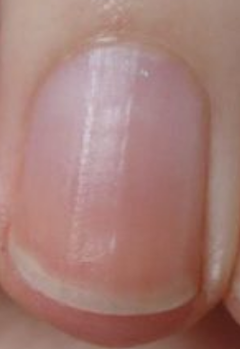normal#54 = 1  
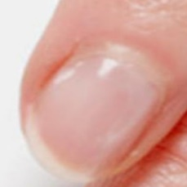normal#0 = 1  
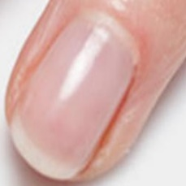normal#2 = 1  
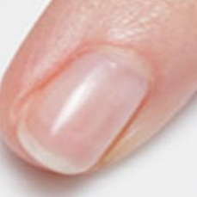normal#3 = 1  
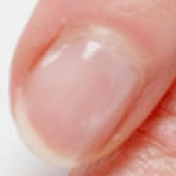normal#8 = 1  
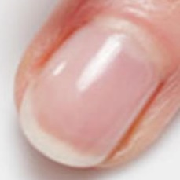normal#9 = 1  
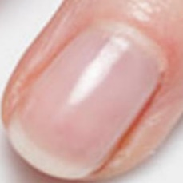normal#10 = 1  
normal#20 = 1  
normal#21 = 1  
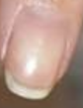normal#34 = 1  
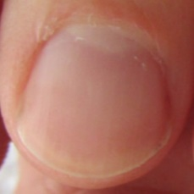normal#38 = 1  
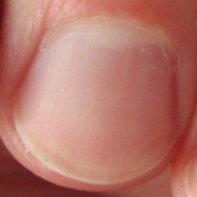normal#39 = 1  
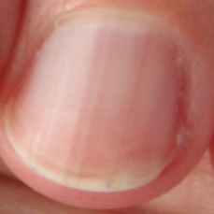normal#40 = 1  
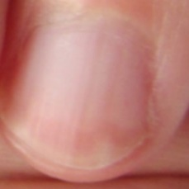normal#41 = 1  
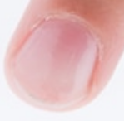normal#43 = 1  
normal#44 = 1  
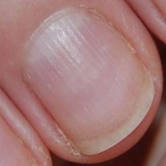normal#49 = 1  
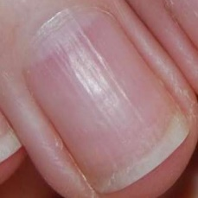normal#50 = 1  
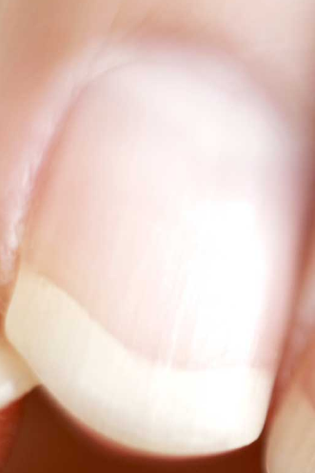normal#64 = 1  
normal#65 = 1  
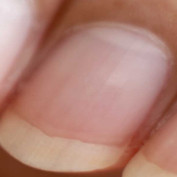normal#66 = 1  
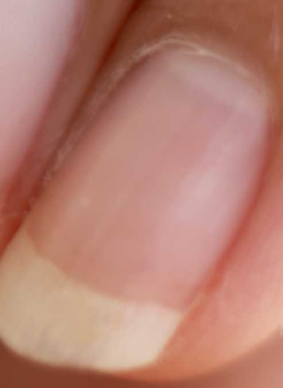normal#67 = 1  
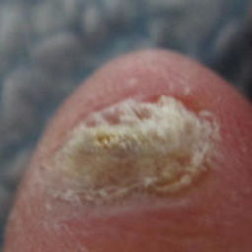fungal#545 = 1  
fungal#37 = 0  
fungal#302 = 0  
fungal#408 = 0  
fungal#393 = 0  
fungal#54 = 0  
fungal#365 = 0  
fungal#367 = 0  
fungal#315 = 0  
fungal#178 = 0  
fungal#353 = 0  
fungal#232 = 0  
fungal#283 = 0  
fungal#31 = 0  
fungal#294 = 0  
fungal#13 = 0  
fungal#218 = 0  
fungal#119 = 0  
fungal#537 = 0  
fungal#275 = 0  
fungal#267 = 0  
fungal#485 = 0  
fungal#146 = 0  
fungal#382 = 0  
fungal#368 = 0  
fungal#36 = 0  
fungal#301 = 0  
fungal#407 = 0  
fungal#78 = 0  
fungal#313 = 0  
fungal#111 = 0  
fungal#513 = 0  
fungal#144 = 0  
fungal#420 = 0  
fungal#236 = 0  
fungal#583 = 0  
fungal#596 = 0  
fungal#524 = 0  
fungal#547 = 0  
fungal#423 = 0  
fungal#363 = 0  
fungal#419 = 0  
fungal#104 = 0  
fungal#82 = 0  
fungal#316 = 0  
fungal#440 = 0  
fungal#88 = 0  
fungal#484 = 0  
fungal#460 = 0  
fungal#398 = 0  
fungal#129 = 0  
fungal#238 = 0  
fungal#543 = 0  
fungal#523 = 0  
fungal#546 = 0  
fungal#86 = 0  
fungal#568 = 0  
fungal#580 = 0  
fungal#514 = 0  
fungal#0 = 0  
fungal#89 = 0  
fungal#335 = 0  
fungal#498 = 0  
fungal#534 = 0  
fungal#421 = 0  
fungal#477 = 0  
fungal#499 = 0  
fungal#28 = 0  
fungal#237 = 0  
fungal#292 = 0  
fungal#90 = 0  
fungal#336 = 0  
fungal#362 = 0  
fungal#204 = 0  
fungal#466 = 0  
fungal#525 = 0  
fungal#548 = 0  
fungal#435 = 0  
fungal#141 = 0  
fungal#30 = 0  
fungal#409 = 0  
fungal#230 = 0  
fungal#140 = 0  
fungal#542 = 0  
fungal#422 = 0  
fungal#160 = 0  
fungal#64 = 0  
fungal#551 = 0  
fungal#248 = 0  
fungal#449 = 0  
fungal#527 = 0  
fungal#182 = 0  
fungal#166 = 0  
fungal#458 = 0  
fungal#468 = 0  
fungal#209 = 0  
fungal#361 = 0.0001  
fungal#258 = 0.0001  
fungal#469 = 0.0001  
fungal#611 = 0.0001  
fungal#114 = 0.0001  
fungal#32 = 0.0001  
fungal#296 = 0.0001  
fungal#309 = 0.0001  
fungal#606 = 0.0001  
fungal#5 = 0.0001  
fungal#27 = 0.0001  
fungal#291 = 0.0001  
fungal#103 = 0.0001  
fungal#207 = 0.0001  
fungal#372 = 0.0001  
fungal#179 = 0.0001  
fungal#617 = 0.0001  
fungal#430 = 0.0001  
fungal#319 = 0.0001  
fungal#314 = 0.0001  
fungal#429 = 0.0001  
fungal#360 = 0.0001  
fungal#186 = 0.0001  
fungal#452 = 0.0001  
fungal#250 = 0.0002  
fungal#609 = 0.0002  
fungal#55 = 0.0002  
fungal#366 = 0.0002  
fungal#317 = 0.0002  
fungal#396 = 0.0002  
fungal#15 = 0.0002  
fungal#247 = 0.0002  
fungal#163 = 0.0002  
fungal#48 = 0.0002  
fungal#22 = 0.0002  
fungal#235 = 0.0002  
fungal#288 = 0.0002  
fungal#380 = 0.0002  
fungal#446 = 0.0002  
fungal#395 = 0.0002  
fungal#511 = 0.0003  
fungal#425 = 0.0003  
fungal#612 = 0.0003  
fungal#242 = 0.0003  
fungal#276 = 0.0003  
fungal#192 = 0.0003  
fungal#399 = 0.0003  
fungal#143 = 0.0003  
fungal#405 = 0.0004  
fungal#57 = 0.0004  
fungal#73 = 0.0004  
fungal#21 = 0.0004  
fungal#287 = 0.0004  
fungal#159 = 0.0004  
fungal#414 = 0.0004  
fungal#7 = 0.0004  
fungal#246 = 0.0004  
fungal#379 = 0.0004  
fungal#65 = 0.0004  
fungal#502 = 0.0005  
fungal#375 = 0.0005  
fungal#518 = 0.0005  
fungal#67 = 0.0005  
fungal#189 = 0.0005  
fungal#438 = 0.0005  
fungal#549 = 0.0005  
fungal#462 = 0.0006  
fungal#205 = 0.0006  
fungal#150 = 0.0006  
fungal#273 = 0.0006  
fungal#92 = 0.0007  
fungal#343 = 0.0007  
fungal#158 = 0.0007  
fungal#411 = 0.0007  
fungal#91 = 0.0007  
fungal#337 = 0.0007  
fungal#95 = 0.0008  
fungal#131 = 0.0008  
fungal#394 = 0.0008  
fungal#168 = 0.0009  
fungal#474 = 0.0009  
fungal#6 = 0.0009  
fungal#198 = 0.001  
fungal#341 = 0.001  
fungal#72 = 0.001  
fungal#76 = 0.001  
fungal#300 = 0.001  
fungal#509 = 0.001  
fungal#605 = 0.001  
fungal#117 = 0.0011  
fungal#84 = 0.0012  
fungal#322 = 0.0012  
fungal#310 = 0.0014  
fungal#345 = 0.0014  
fungal#426 = 0.0014  
fungal#505 = 0.0015  
fungal#540 = 0.0016  
fungal#444 = 0.0017  
fungal#77 = 0.0017  
fungal#320 = 0.0018  
fungal#497 = 0.0018  
fungal#522 = 0.0018  
fungal#278 = 0.0018  
fungal#389 = 0.0019  
fungal#410 = 0.0019  
fungal#400 = 0.002  
fungal#447 = 0.002  
fungal#153 = 0.0021  
fungal#165 = 0.0021  
fungal#526 = 0.0021  
fungal#581 = 0.0023  
fungal#624 = 0.0023  
fungal#416 = 0.0023  
fungal#553 = 0.0025  
fungal#16 = 0.0026  
fungal#43 = 0.0026  
fungal#282 = 0.0026  
fungal#11 = 0.0028  
fungal#373 = 0.0028  
fungal#128 = 0.0032  
fungal#297 = 0.0037  
fungal#252 = 0.0038  
fungal#1 = 0.0041  
fungal#588 = 0.0042  
fungal#629 = 0.0042  
fungal#172 = 0.0043  
fungal#136 = 0.0047  
fungal#152 = 0.0048  
fungal#162 = 0.0048  
fungal#378 = 0.0051  
fungal#535 = 0.0055  
fungal#531 = 0.006  
fungal#139 = 0.0062  
fungal#532 = 0.0062  
fungal#324 = 0.0064  
fungal#197 = 0.0068  
fungal#486 = 0.0068  
fungal#210 = 0.0068  
fungal#334 = 0.0068  
fungal#68 = 0.0075  
fungal#508 = 0.0077  
fungal#74 = 0.0079  
fungal#233 = 0.0079  
fungal#481 = 0.0084  
fungal#557 = 0.0085  
fungal#561 = 0.0085  
fungal#572 = 0.0085  
fungal#604 = 0.0085  
fungal#40 = 0.0088  
fungal#305 = 0.0088  
fungal#454 = 0.0095  
fungal#554 = 0.0098  
fungal#427 = 0.0099  
fungal#116 = 0.0105  
fungal#81 = 0.011  
fungal#311 = 0.011  
fungal#439 = 0.0122  
fungal#224 = 0.0131  
fungal#359 = 0.0131  
fungal#377 = 0.0133  
fungal#66 = 0.0134  
fungal#552 = 0.0158  
fungal#25 = 0.017  
fungal#2 = 0.0171  
fungal#167 = 0.0177  
fungal#590 = 0.0185  
fungal#285 = 0.0191  
fungal#392 = 0.0192  
fungal#461 = 0.0196  
fungal#244 = 0.0222  
fungal#424 = 0.0223  
fungal#173 = 0.0251  
fungal#358 = 0.0263  
fungal#83 = 0.0265  
fungal#277 = 0.0272  
fungal#326 = 0.0274  
fungal#329 = 0.0274  
fungal#41 = 0.028  
fungal#234 = 0.0285  
fungal#333 = 0.0297  
fungal#417 = 0.0314  
fungal#496 = 0.0333  
fungal#519 = 0.0333  
fungal#390 = 0.0335  
fungal#441 = 0.0341  
fungal#593 = 0.0402  
fungal#145 = 0.0405  
fungal#591 = 0.0432  
fungal#4 = 0.0437  
fungal#456 = 0.0455  
fungal#19 = 0.0457  
fungal#307 = 0.0457  
fungal#381 = 0.0485  
fungal#151 = 0.0494  
fungal#254 = 0.0494  
fungal#437 = 0.0498  
fungal#610 = 0.0506  
fungal#448 = 0.051  
fungal#87 = 0.0607  
fungal#328 = 0.0607  
fungal#376 = 0.0627  
fungal#220 = 0.0675  
fungal#457 = 0.0755  
fungal#35 = 0.0757  
fungal#12 = 0.0769  
fungal#274 = 0.0769  
fungal#521 = 0.0773  
fungal#58 = 0.0837  
fungal#170 = 0.0859  
fungal#529 = 0.0866  
fungal#96 = 0.0877  
fungal#29 = 0.088  
fungal#61 = 0.088  
fungal#293 = 0.088  
fungal#550 = 0.088  
fungal#69 = 0.0971  
fungal#451 = 0.0974  
fungal#93 = 0.0974  
fungal#106 = 0.0984  
fungal#349 = 0.0984  
fungal#70 = 0.1044  
fungal#24 = 0.1055  
fungal#290 = 0.1055  
fungal#332 = 0.1055  
fungal#268 = 0.1059  
fungal#222 = 0.1088  
fungal#217 = 0.1113  
fungal#369 = 0.1136  
fungal#109 = 0.1152  
fungal#352 = 0.1152  
fungal#261 = 0.122  
fungal#50 = 0.1274  
fungal#453 = 0.1308  
fungal#442 = 0.1377  
normal#24 = 0.1476  
fungal#113 = 0.149  
fungal#428 = 0.1492  
fungal#101 = 0.1506  
fungal#3 = 0.1557  
fungal#100 = 0.1625  
fungal#108 = 0.165  
fungal#351 = 0.165  
fungal#18 = 0.1696  
fungal#472 = 0.1705  
fungal#607 = 0.1877  
fungal#102 = 0.1955  
fungal#266 = 0.1962  
fungal#479 = 0.1962  
fungal#17 = 0.2021  
fungal#245 = 0.2153  
fungal#587 = 0.2205  
fungal#628 = 0.2205  
fungal#490 = 0.2273  
fungal#594 = 0.229  
fungal#251 = 0.2518  
fungal#478 = 0.2563  
fungal#206 = 0.2616  
fungal#354 = 0.2616  
fungal#589 = 0.2781  
fungal#592 = 0.2781  
fungal#85 = 0.3318  
fungal#323 = 0.3318  
fungal#20 = 0.3578  
fungal#286 = 0.3578  
fungal#344 = 0.3632  
fungal#528 = 0.3634  
fungal#133 = 0.3701  
fungal#56 = 0.4084  
fungal#465 = 0.4163  
fungal#120 = 0.4246  
fungal#576 = 0.4272  
fungal#622 = 0.4272  
fungal#49 = 0.4456  
fungal#431 = 0.4572  
fungal#582 = 0.4601  
fungal#625 = 0.4601  
fungal#455 = 0.4638  
fungal#213 = 0.4845  
fungal#412 = 0.4875  
fungal#23 = 0.4918  
fungal#289 = 0.4918  
fungal#331 = 0.4918  
fungal#175 = 0.4933  
fungal#127 = 0.4935  
fungal#364 = 0.4935  
fungal#616 = 0.4957  
fungal#346 = 0.5178  
fungal#47 = 0.5466  
fungal#562 = 0.5511  
fungal#578 = 0.5511  
fungal#98 = 0.553  
fungal#265 = 0.5673  
fungal#415 = 0.5857  
fungal#123 = 0.5978  
fungal#231 = 0.6045  
fungal#570 = 0.605  
fungal#602 = 0.605  
fungal#569 = 0.6153  
fungal#630 = 0.6153  
fungal#257 = 0.6208  
fungal#228 = 0.6208  
fungal#342 = 0.6277  
fungal#374 = 0.6338  
fungal#585 = 0.6339  
fungal#321 = 0.6994  
fungal#598 = 0.7066  
fungal#262 = 0.7156  
fungal#156 = 0.7159  
fungal#180 = 0.7159  
fungal#132 = 0.7168  
fungal#432 = 0.7659  
fungal#135 = 0.7752  
fungal#563 = 0.7817  
fungal#579 = 0.7817  
fungal#199 = 0.7896  
fungal#295 = 0.8017  
fungal#10 = 0.8084  
fungal#216 = 0.8084  
fungal#556 = 0.8178  
fungal#559 = 0.8178  
fungal#571 = 0.8178  
fungal#603 = 0.8178  
fungal#164 = 0.8219  
fungal#450 = 0.8219  
fungal#44 = 0.83  
fungal#339 = 0.83  
fungal#122 = 0.8314  
fungal#142 = 0.8353  
fungal#495 = 0.8465  
fungal#512 = 0.8465  
fungal#219 = 0.8527  
fungal#566 = 0.8545  
fungal#626 = 0.8545  
fungal#118 = 0.8596  
fungal#130 = 0.8669  
fungal#327 = 0.8685  
fungal#94 = 0.8758  
fungal#560 = 0.8765  
fungal#577 = 0.8765  
fungal#401 = 0.8852  
fungal#608 = 0.886  
fungal#214 = 0.8867  
fungal#38 = 0.9  
fungal#303 = 0.9  
fungal#503 = 0.9004  
fungal#510 = 0.9004  
fungal#196 = 0.9006  
fungal#483 = 0.9057  
fungal#227 = 0.9084  
fungal#148 = 0.912  
fungal#471 = 0.9144  
fungal#480 = 0.9152  
fungal#53 = 0.9165  
fungal#492 = 0.9165  
fungal#97 = 0.9189  
fungal#620 = 0.9193  
fungal#154 = 0.9266  
fungal#171 = 0.9266  
fungal#241 = 0.9275  
normal#13 = 0.9275  
fungal#161 = 0.9292  
fungal#436 = 0.9292  
fungal#501 = 0.9313  
fungal#211 = 0.9333  
fungal#613 = 0.9337  
fungal#115 = 0.9476  
fungal#121 = 0.9491  
fungal#338 = 0.9491  
fungal#71 = 0.9502  
fungal#284 = 0.9502  
fungal#75 = 0.951  
fungal#45 = 0.952  
fungal#200 = 0.9536  
fungal#239 = 0.9547  
fungal#586 = 0.9577  
fungal#203 = 0.9618  
fungal#491 = 0.9618  
fungal#62 = 0.9651  
fungal#42 = 0.9657  
normal#14 = 0.9663  
fungal#181 = 0.9663  
fungal#269 = 0.9681  
fungal#384 = 0.9681  
fungal#190 = 0.9689  
fungal#433 = 0.9689  
fungal#99 = 0.9706  
fungal#63 = 0.975  
fungal#147 = 0.9752  
fungal#383 = 0.9752  
fungal#506 = 0.9757  
fungal#475 = 0.9757  
fungal#260 = 0.9758  
fungal#225 = 0.9761  
normal#46 = 0.9767  
fungal#467 = 0.9771  
fungal#418 = 0.9774  
fungal#391 = 0.9784  
fungal#52 = 0.9789  
fungal#176 = 0.9807  
fungal#169 = 0.9814  
fungal#340 = 0.9837  
normal#16 = 0.9861  
fungal#51 = 0.9863  
fungal#229 = 0.9869  
fungal#259 = 0.9871  
fungal#185 = 0.9875  
fungal#126 = 0.988  
fungal#34 = 0.9884  
fungal#138 = 0.9884  
fungal#299 = 0.9884  
fungal#8 = 0.9888  
fungal#623 = 0.9899  
fungal#567 = 0.9909  
fungal#627 = 0.9909  
fungal#397 = 0.9916  
fungal#564 = 0.9916  
fungal#565 = 0.9916  
fungal#614 = 0.9916  
fungal#263 = 0.9919  
fungal#387 = 0.992  
fungal#256 = 0.9921  
fungal#516 = 0.9924  
fungal#79 = 0.9929  
fungal#306 = 0.9929  
fungal#601 = 0.9929  
fungal#539 = 0.9931  
fungal#584 = 0.9932  
fungal#615 = 0.9932  
fungal#183 = 0.9933  
fungal#574 = 0.9934  
fungal#619 = 0.9934  
fungal#555 = 0.9936  
fungal#600 = 0.9936  
fungal#558 = 0.9939  
fungal#476 = 0.9939  
fungal#599 = 0.9942  
fungal#371 = 0.9944  
fungal#201 = 0.9949  
fungal#487 = 0.9949  
normal#33 = 0.9951  
fungal#191 = 0.9955  
fungal#249 = 0.9962  
fungal#9 = 0.9964  
fungal#215 = 0.9964  
fungal#281 = 0.9964  
normal#19 = 0.9965  
fungal#357 = 0.9966  
fungal#470 = 0.9971  
fungal#493 = 0.9974  
fungal#370 = 0.9977  
fungal#355 = 0.9978  
fungal#595 = 0.9978  
fungal#631 = 0.9978  
fungal#520 = 0.9978  
fungal#177 = 0.9979  
fungal#174 = 0.9981  
normal#15 = 0.9982  
fungal#280 = 0.9983  
fungal#157 = 0.9984  
fungal#188 = 0.9984  
fungal#105 = 0.9984  
fungal#459 = 0.9985  
fungal#46 = 0.9988  
fungal#318 = 0.9988  
fungal#541 = 0.9988  
fungal#434 = 0.9988  
fungal#272 = 0.9989  
fungal#489 = 0.9989  
fungal#264 = 0.999  
fungal#464 = 0.999  
fungal#538 = 0.9991  
fungal#255 = 0.9991  
fungal#443 = 0.9991  
fungal#195 = 0.9991  
fungal#155 = 0.9992  
normal#45 = 0.9992  
fungal#403 = 0.9992  
fungal#134 = 0.9993  
fungal#202 = 0.9993  
fungal#488 = 0.9993  
normal#59 = 0.9994  
fungal#107 = 0.9994  
fungal#350 = 0.9994  
fungal#26 = 0.9994  
normal#27 = 0.9994  
fungal#573 = 0.9995  
fungal#618 = 0.9995  
fungal#149 = 0.9995  
fungal#402 = 0.9995  
fungal#253 = 0.9995  
normal#25 = 0.9996  
normal#60 = 0.9996  
fungal#14 = 0.9996  
fungal#279 = 0.9996  
fungal#597 = 0.9996  
fungal#494 = 0.9996  
normal#26 = 0.9996  
fungal#60 = 0.9996  
fungal#243 = 0.9996  
normal#17 = 0.9996  
fungal#544 = 0.9997  
fungal#406 = 0.9997  
fungal#270 = 0.9998  
fungal#385 = 0.9998  
fungal#325 = 0.9998  
fungal#39 = 0.9998  
fungal#304 = 0.9998  
fungal#413 = 0.9998  
fungal#388 = 0.9998  
fungal#515 = 0.9998  
fungal#187 = 0.9998  
normal#28 = 0.9998  
normal#35 = 0.9998  
fungal#184 = 0.9998  
fungal#193 = 0.9999  
fungal#347 = 0.9999  
fungal#271 = 0.9999  
fungal#386 = 0.9999  
normal#58 = 0.9999  
normal#29 = 0.9999  
fungal#125 = 0.9999  
fungal#500 = 0.9999  
fungal#517 = 0.9999  
fungal#504 = 0.9999  
fungal#112 = 0.9999  
normal#62 = 0.9999  
fungal#330 = 0.9999  
normal#52 = 0.9999  
fungal#463 = 0.9999  
fungal#482 = 0.9999  
fungal#507 = 0.9999  
fungal#59 = 0.9999  
fungal#240 = 0.9999  
fungal#536 = 0.9999  
fungal#575 = 0.9999  
fungal#621 = 0.9999  
fungal#80 = 1  
fungal#308 = 1  
fungal#33 = 1  
fungal#137 = 1  
fungal#298 = 1  
fungal#208 = 1  
normal#12 = 1  
fungal#212 = 1  
normal#57 = 1  
normal#55 = 1  
normal#47 = 1  
fungal#445 = 1  
fungal#530 = 1  
normal#63 = 1  
normal#48 = 1  
normal#61 = 1  
fungal#533 = 1  
normal#51 = 1  
fungal#194 = 1  
fungal#348 = 1  
fungal#110 = 1  
normal#36 = 1  
normal#37 = 1  
fungal#223 = 1  
normal#23 = 1  
normal#56 = 1  
normal#7 = 1  
fungal#312 = 1  
normal#6 = 1  
fungal#404 = 1  
normal#30 = 1  
fungal#124 = 1  
fungal#221 = 1  
fungal#356 = 1  
normal#22 = 1  
normal#5 = 1  
normal#32 = 1  
normal#42 = 1  
fungal#226 = 1  
fungal#473 = 1  
normal#1 = 1  
normal#4 = 1  
normal#11 = 1  
normal#18 = 1  
normal#31 = 1  
normal#53 = 1  
normal#54 = 1  
normal#0 = 1  
normal#2 = 1  
normal#3 = 1  
normal#8 = 1  
normal#9 = 1  
normal#10 = 1  
normal#20 = 1  
normal#21 = 1  
normal#34 = 1  
normal#38 = 1  
normal#39 = 1  
normal#40 = 1  
normal#41 = 1  
normal#43 = 1  
normal#44 = 1  
normal#49 = 1  
normal#50 = 1  
normal#64 = 1  
normal#65 = 1  
normal#66 = 1  
normal#67 = 1  
fungal#545 = 1